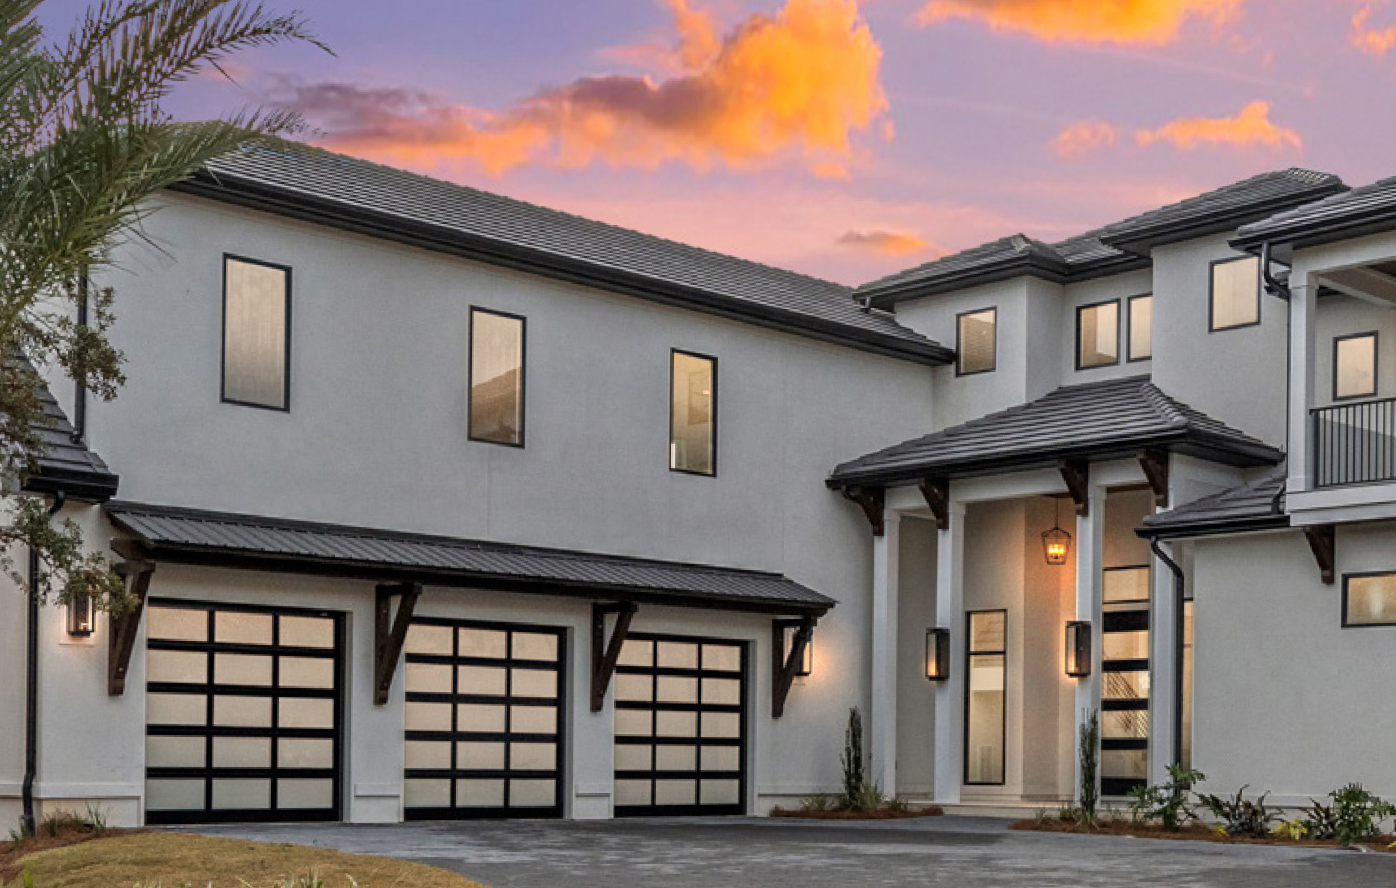


StyleView™, Black, Satin Glass

Residential Sectional Overview
Homeowners Guide to Garage Doors
Whether you are looking to enhance your home's curb appeal, add resale value, or improve garage door safety and security, Raynor Garage Doors has the residential garage door products to suit your needs.

What to Look for in a Garage Door
There are four basic types of doors for residential properties:
Pan Door (Polystyrene Insulation Optional): TradeMark™ and BuildMark®
Polystyrene Insulated Door: Encore™ EN200
Polyurethane Insulated Door: Aspen™ AP200, Aspen™ AP138, Aspen™ AP200N, Aspen™ AP200LV, Country Manor™, RockCreeke™, Eden Coast by Raynor® , and Revival Wood Collection™
Aluminum Rail and Stile Glass Doors: Raynor StyleView

With the exception of the Aluminum/Glass door, they can look very similar from the outside. So what is the correct door for your application? Why the different types?

Let's start with insulation:
Consider these two key elements:
- What type of climate do you live in?
- Is your garage attached? Detached? Underneath rooms (bi-level)?

Pan doors and aluminum rail and stile glass doors are not insulated. They offer virtually no thermal efficiency. Pan doors are a good choice for detached garages, or moderate climates with an attached garage. However, insulation can be added to pan doors for minimal thermal efficiency and noise suppression. Aluminum rail and stile glass doors are a great choice if aesthetics are the main concern.

Polystyrene insulated doors have three layers. Polystyrene insulation is bonded between two layers of steel providing thermal protection. These doors are a good choice for harsher climates (both cold and heat) as well as attached garages. Many aesthetic options and design elements are available to tailor these doors to your house for exceptional curb appeal.

Polyurethane insulated doors also have three layers. However, these doors feature a “foam-in-place” insulation that entirely fills all voids between the two layers of steel. Polyurethane offers the best thermal efficiency available. This is an excellent choice for attached garages, garages that are underneath rooms and harsh climates (both hot and cold). Our Aspen™ polyurethane doors also feature Raynor's proprietary WeatherLock™ section joint and seal system. As with our polystyrene doors, many aesthetic options and design elements are available.

What about windows?
Windows can add a tremendous amount of curb appeal to your door and overall appearance of your home. There are many window options available, and consider the type of door you selected to choose the correct glass. For instance, with a pan door you can choose single pane glass, but if you need an insulated door, always select insulated glass to maintain as much thermal protection as possible.

Dress it up!
Raynor has many options that can be added to increase your curb appeal. You have a choice of panel designs, color options and decorative hardware in the form of straps and handles. Don’t forget about the inside of the garage. You can upgrade from conventional galvanized hardware to EnduraCote™ hardware - a clean white powder coat system for your track and hardware and black powder coated springs and torsion tube, and add to your warranty period at the same time.

Raynor has a wide variety of doors and options to customize your garage door to your house, giving a perfect fit to your needs.





Wind Load

Homeowners Guide to Garage Doors
Products featuring the Raynor Secure icon are available with Wind Load approved designs. See your Raynor Dealer for more details.

Raynor Recycles


Products featuring the Raynor Recycles icon are manufactured with recycled material to maintain the environment.

Creating garage doors of distinction requires the ultimate attention to detail. Raynor Distinctions Series garage doors offer the finest features the garage door industry has to offer, combined with the widest range of design options available.

Revival Wood Collection™
Eden Coast by Raynor®
Country Manor™

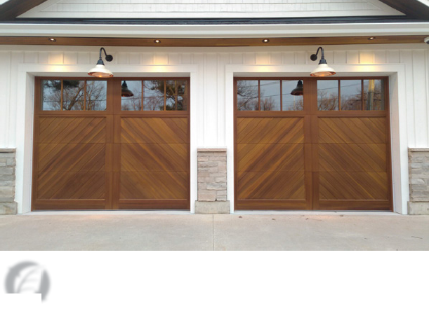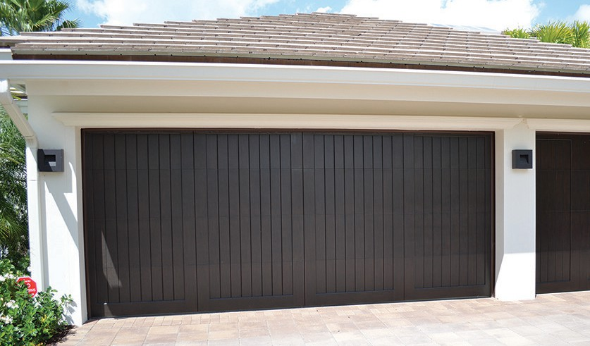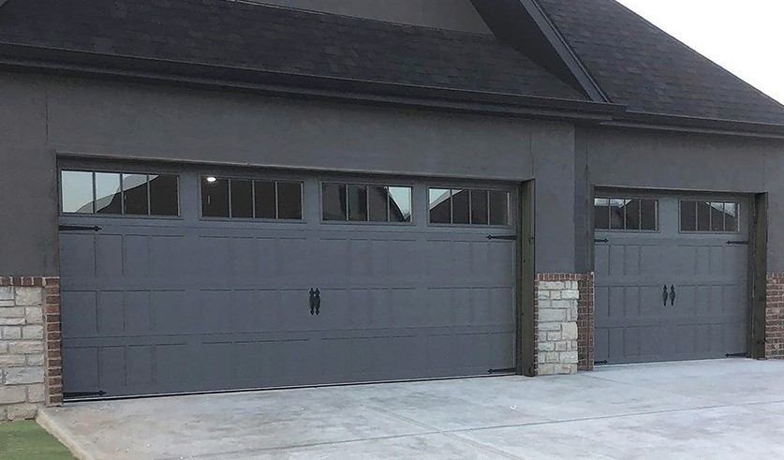

Environmentally Friendly

- High end wood look
- Full wood overlay garage doors to achieve high end wood look
- NeuFoam™ polyurethane insulation
- WeatherLock™ section joint prevents any water from coming into your garage
- Multiple finishes and materials allow us to offer these doors in a wide assortment of traditional or contemporary designs for a custom look
- All of our windows are custom built for a one of a kind look, choose from a variety of glass options.
- Enduracote™ track, springs and hardware come standard

 Environmentally Friendly
Tested U-Factor | 0.17
Calculated R-Value | 18.3

- High end wood look without the maintenance
- Composite full overlay garage doors to achieve high end wood look without the maintenance
- NeuFoam™ polyurethane insulation
- WeatherLock™ section joint prevents any water from coming into your garage
- Unique finishing techniques allow us to offer our doors in a wide assortment of traditional wood colors, custom designs are available
- All of our windows are custom built for a one of a kind look, choose from a variety of glass options, single pane or insulated glass is available

 Environmentally Friendly
Tested U-Factor | 0.17
Calculated R-Value | 18.0

- Composite inlay carriage house garage door
- NeuFoam™ polyurethane insulation
- Steel, two-sided
- White, Almond, Desert Tan, Sandstone, Bronze, Brown, Slate, Black
- Arched or square window designs
- Decorative hardware options add a finishing touch.
- Features “For As Long As You Own Your Home” sections limited warranty against rust, 6-years limited warranty on hardware, and a 3-years limited warranty on springs to the original purchaser*

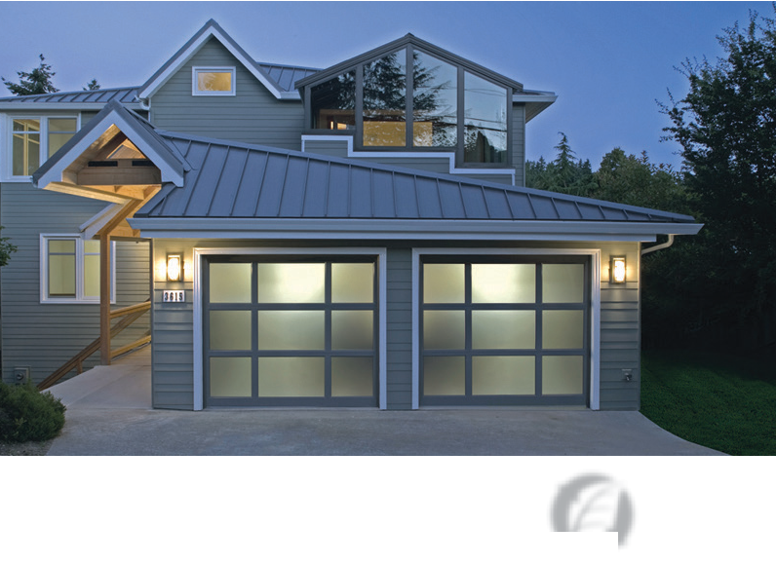



RockCreeke™ Raynor StyleView™

Tested U-Factor | 0.20
Calculated R-Value | 13.0

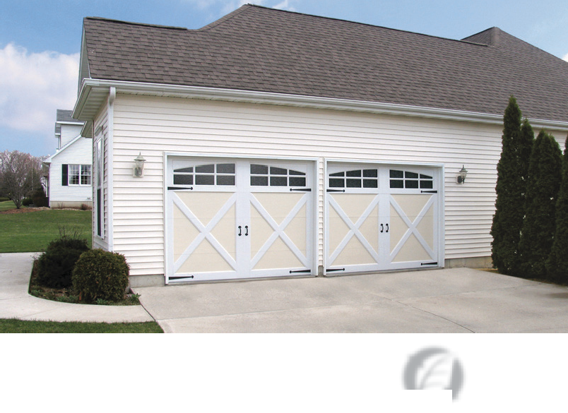


Wind Load Approved
Environmentally Friendly
Wind Load Approved
Environmentally Friendly

  - Composite partial overlay carriage house garage door
Distinctions Series™
* See www.raynor.com/products for complete and full Limited Warranty details.
  - NeuFoam™ polyurethane insulation
  - Steel, two-sided
  - White, Almond, Black, Bronze, Brown, Desert Tan, Sandstone, Charcoal for Base or Board Colors
  - EnduraCote™ painted track and hardware options
  - Arched or square top designs
  - Decorative hardware options add a finishing touch
  - Optional clear, insulated and water glass available
  - Features “For As Long As You Own Your Home” sections limited warranty against rust-through, trim boards for 5-years against discoloration and 10-years against delamination*
  - ColorWave™: Choose from 1,500 Sherwin-Williams® colors to custom match your door to your home
- Aluminum rail and stile garage door
- 188 ArmorBrite™ powder coat colors available
- 3 anodized finish options available
- Elegant Finish Woodtones™
- Carriage House and Mixed Panel designs available
- 2 EnduraCote™ powder coated track and hardware options
- Alternate color kick panel options
- Dozens of glass designs to choose from including tinted, frosted, acrylic, polycarbonate and more
- Features “For As Long As You Own Your Home” section limited warranty against defects in materials and workmanship, and 5-years for ArmorBrite finish*

Design Options
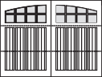
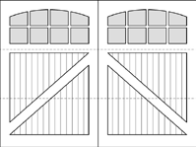
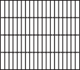
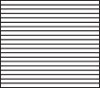
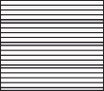
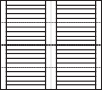
Traditional Contemporary

Window Options

All options are available as one or two-car configurations and
square or arched top sections. 1 Pane

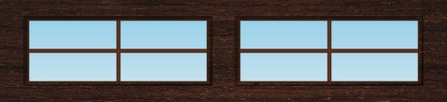

Bentley Bracebridge Style 1 Style 2 Style 3 Style 4
2 Over 2 Pane

3 Pane
2 Pane
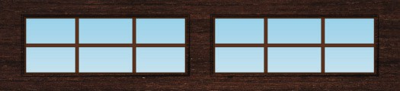
3 Over 3 Pane

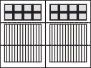
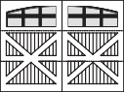
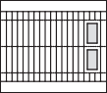
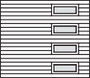
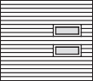
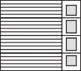
Crosshill
Harmony
Style 5 Style 6 Style 7 Style 8

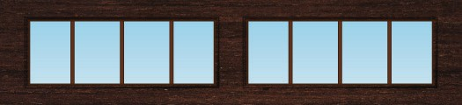
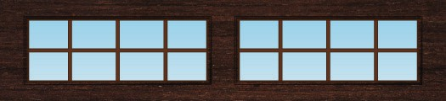
4 Pane 4 Over 4 Pane

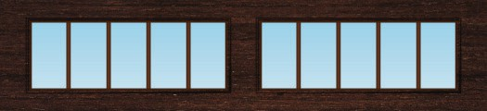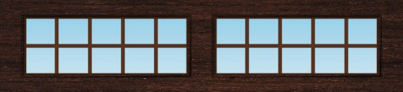

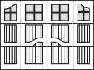
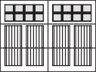
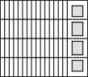
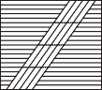
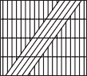
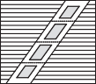
Harrington Linwood Style 9 Style 10 Style 11 Style 12
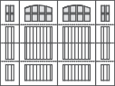
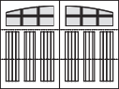
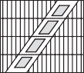
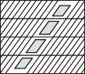
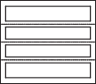
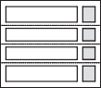
Owen Sound Oxford Style 13 Style 14 Style 15 Style 16

Glass
5 Pane
5 Over 5 Pane

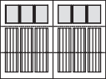
Shakespeare

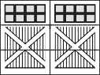
Stratford

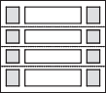
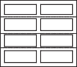
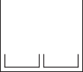
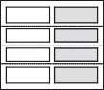
Style 17 Style 18 Style 19 Style 20

Clear
Satin

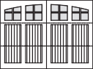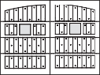

Waterloo Windsor Style 21 Style 22 Style 23 Style 24
Obscure
Grey Tint
Super Grey Tint

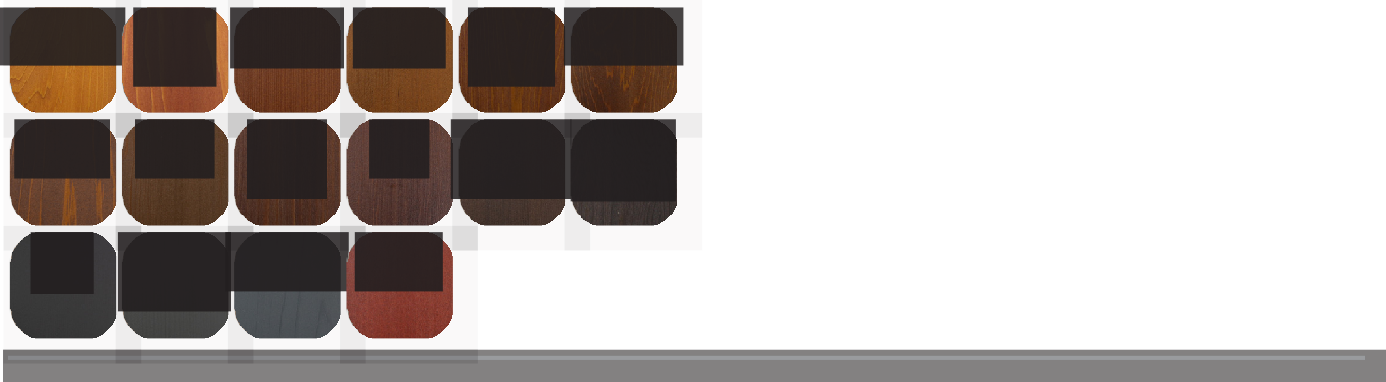
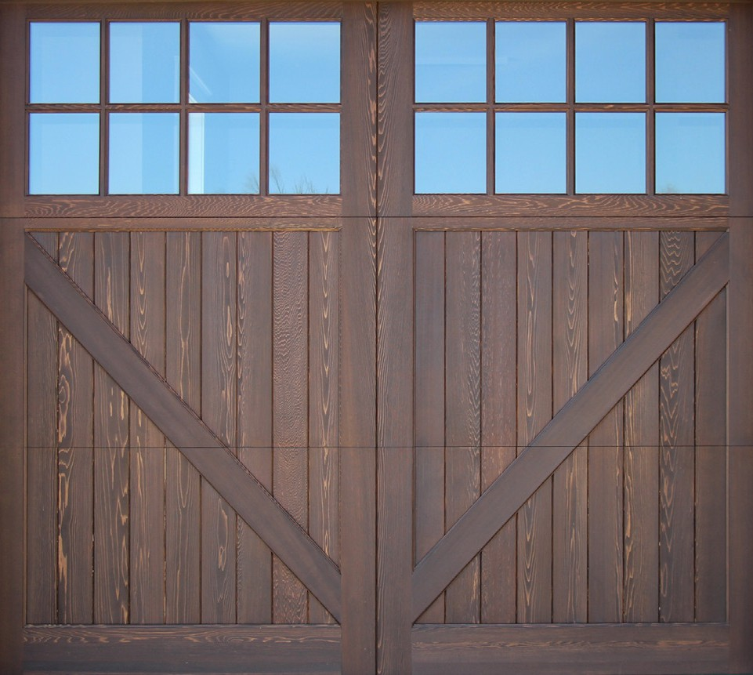


Revival Wood Collection™
Roasted
Almond
*Stain colors are shown on cedar, additional wood species and composite options are also available. Choice of overlay material will influence the door’s final appearance. The swatches shown on monitors and printed materials may vary from the actual color. For a true representation of the color, visit your local Raynor Dealer.
Revival Wood Collection, #004 Oxford Dark Oak, Bracebridge
#1108
Crimson
#005
Bedford Blue
#011
Oxford Iron Ore
#27
Onyx
#34 #004 #009
Teak Oxford Dark Brown
Oak Mahogany
#3450
Special Walnut
#1134 #70
Caliwood Walnut
#1104 #1102
Banff Brown
#1103 #17
Canyon Red Espresso
#1101
Natural Cedar
#1105
Harvest Gold
The Revival Wood Collection is built on a durable 2” Aspen base, featuring custom wood overlays on insulated steel panels for enhanced durability and a calculated
19.25 R-Value. Available in various section heights, including 32” and 28”, each door is custom-built with your choice of finishes, combining the warmth of real wood with flexibility in design.
Stain Finishes
With both paint and stain options available, your door can be customized to match your exterior.
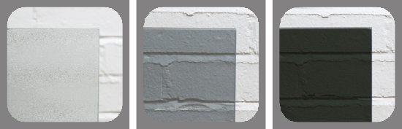
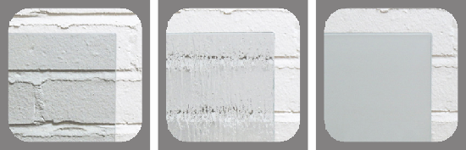
Many other custom options available. Contact your Raynor dealer for further details.
Rain

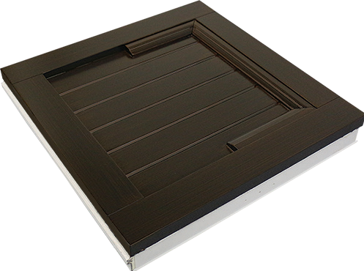
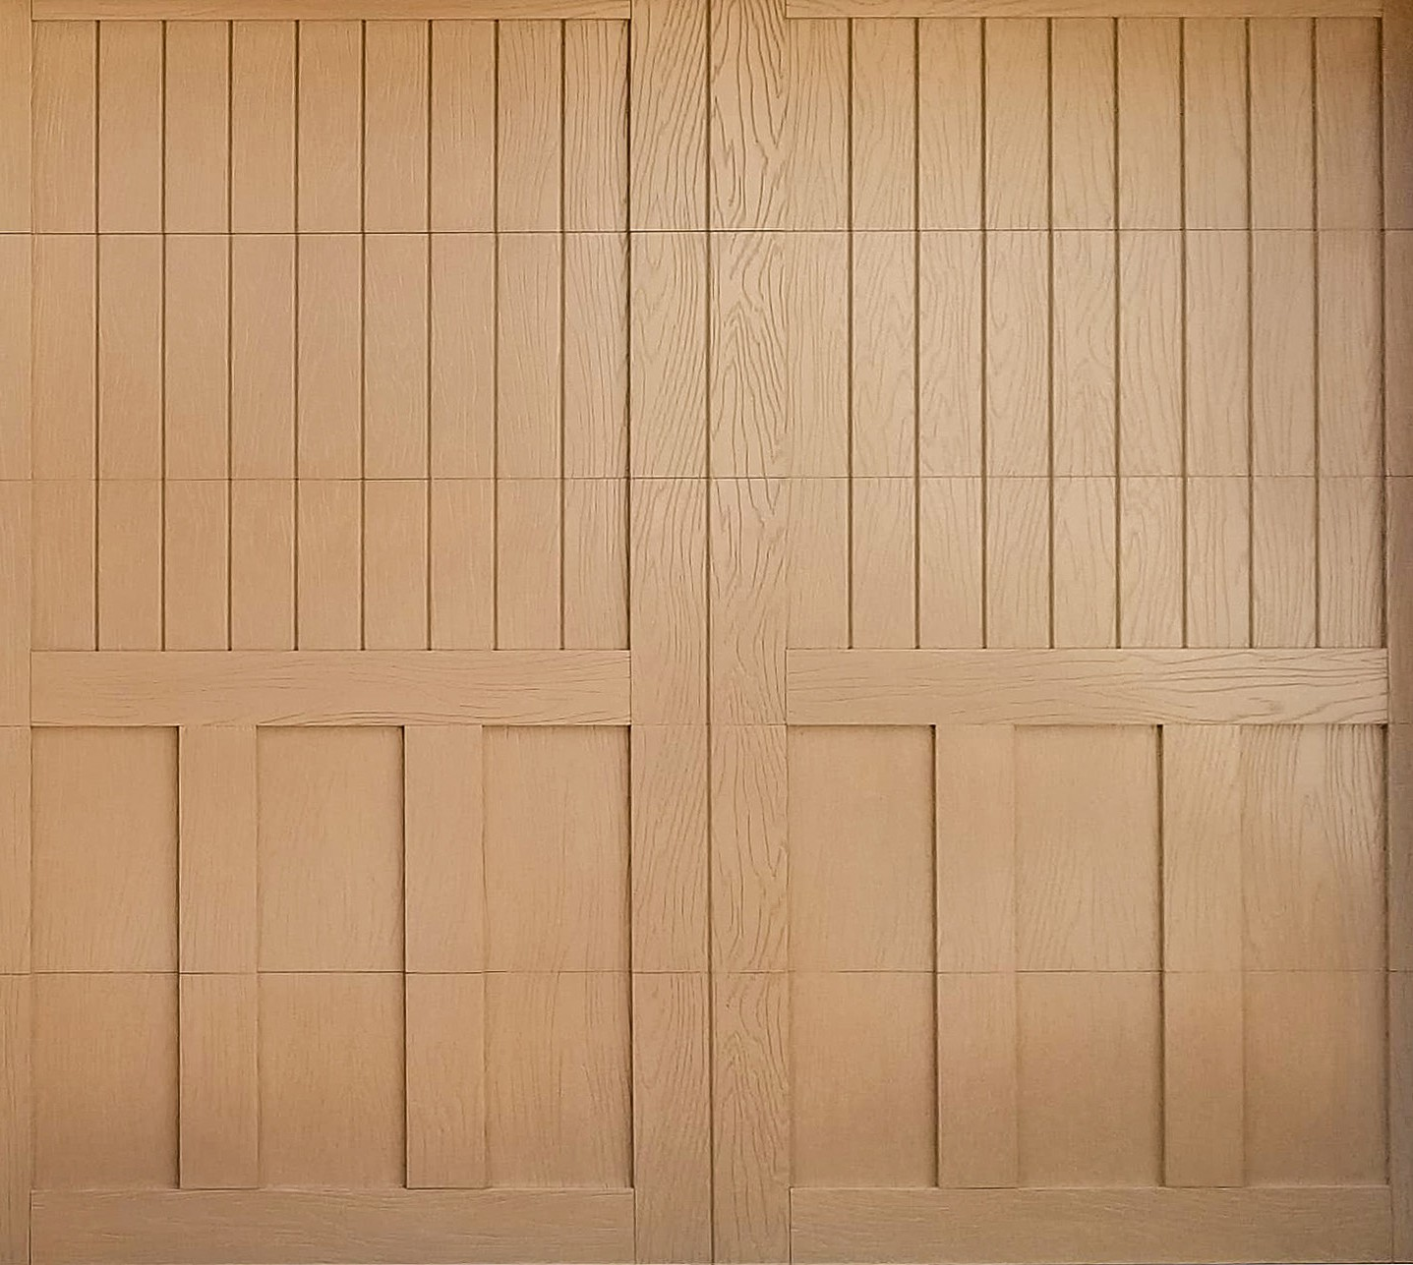
4
2
3
1
5
6

Eden Coast by Raynor®

Eden Coast by Raynor doors are handcrafted by fully overlaying steel sections with environmentally-friendly composite material, providing a high-end wood look without any of the maintenance.
- Environmentally friendly, composite material
- Square, routed, or round over edges available
- Custom inlay molding available on square edge
- Board thickness ranges from 1" to 1¼" to achieve desired detail
- 2" steel sandwich door with NeuFoam™ insulation with an R-Value of 18.3
- Doors come pre-finished in a stain color of your choice

Eden Coast by Raynor® Birmingham, Natural

Stain Finishes
Unique finishing techniques allow us to offer our doors in a variety of traditional wood colors. Finish off your authentic look by choosing an overlay in smooth or woodgrain textures.
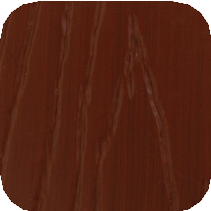
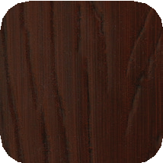
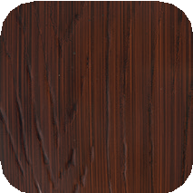
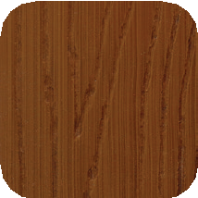
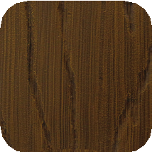
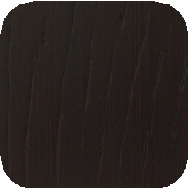
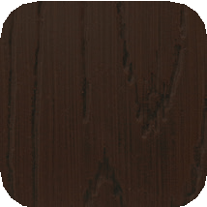
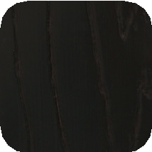
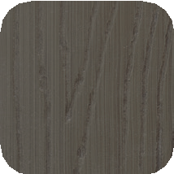
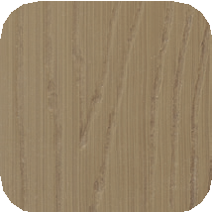
Light Cherry Dark Cherry
Red Mahogany
Dark Cedar
Oak
Red Walnut
Walnut
Mahogany Driftwood
Natural

Design Options
All door designs are available in single or two-car options. Custom designs are also available!

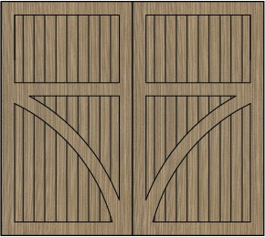 | 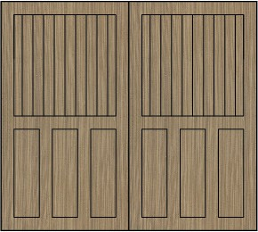 | 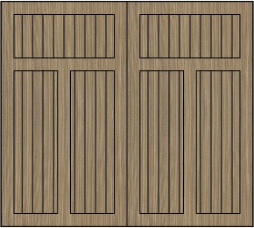 | 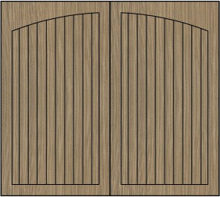 | 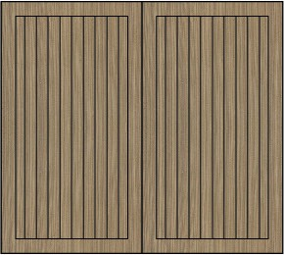 | 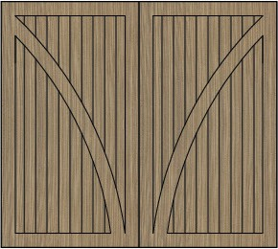 | 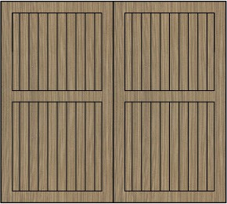 | 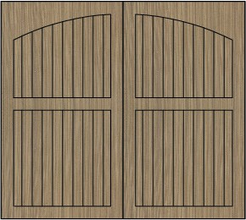
Anderson | Asheville | Birmingham | Bridgemill | Cambridge | Charleston | Hampton | Leatherwood
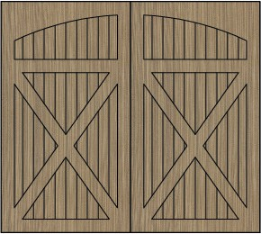 | 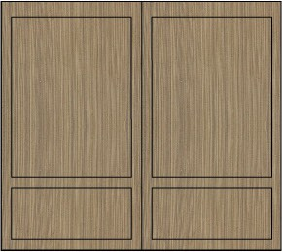 | 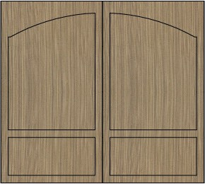 | 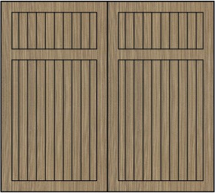 | 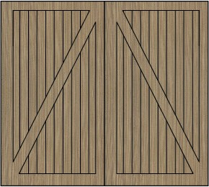 | 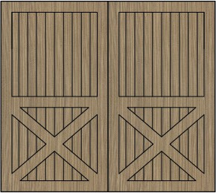 | 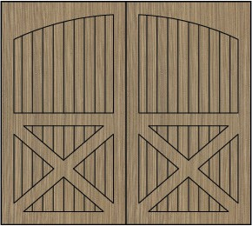 | 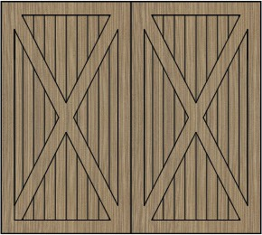
Louisville | Magnolia | Magnolia-Arch | Providence | Saratoga | St. Augustine | Summerhaven | Williamsburg

Window Options
All Eden Coast windows are custom built for a one of a kind look. Choose between clear, obscure, satin, seeded, or rain glass.
 |  |  | 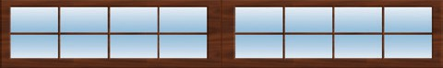
Window A | Window B | Window C | Window D
 | 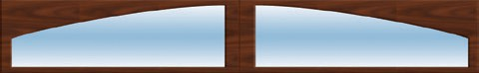 | 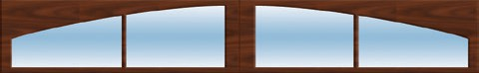 | 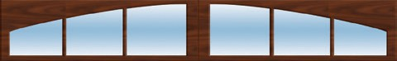
Window E | Window F | Window G | Window H
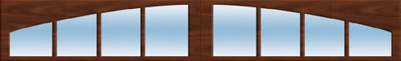 | 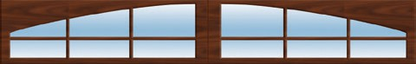 | 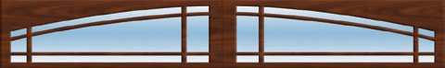
Window I | Window J | Window K

Designed to provide unsurpassed character in a maintenance-free design, Raynor RockCreeke partial overlay doors feature an environmentally stable trim board material.

Colors
- Baked-on finish

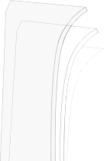





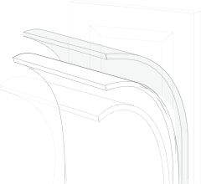




- Epoxy primer
6
3
2
1
4
5
- Galvanized layer
- High-strength steel
- Polyurethane insulation
- High-strength steel

RockCreeke, Bronze over Brown, V-Buck with 3 over 3 clear glass

Optional Track and Decorative Hardware

Base Colors
Handles
Straps

Standard Solid Colors
Black

Charcoal
Board Colors
Tan
Sandstone
Brown Desert
Bronze
White Almond

Standard Solid Color
Optional Solid Colors
Almond Black
Tan
Charcoal
Desert Sandstone
Brown
Bronze
White
Optional Solid Colors

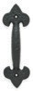
Cast Lift Handle Fleur-de-Lis 6131100
Cast Lift Handle Spear 6131115
Cast Pull Handle Colonial 6131113
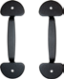
Stamped Pull Handle Spade 6131102
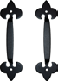
Low Profile Stamped Handle

Cast Pull Handle Fleur-de-Lis 6131117
Cast Pull Handle Spear 6131116
Stamped Lift Handle Spade 6131101
Stamped Bean Handles 2/pack 6130498

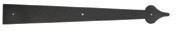
Stamped 16” Hinge
Spade (2” High)
6131105

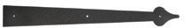
Stamped 24” Hinge Spade 6131106
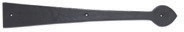
Cast 16” Hinge Spear 6131104

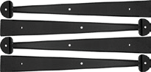
Stamped 17” Bean Straps 4/pack

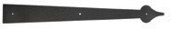
Stamped 16” Hinge Narrow Spade (1⅝” High) 6131111

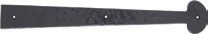
Cast 16” Hinge Colonial 6131114
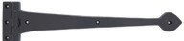
Cast 16” Hinge Assembly Spear 6131103

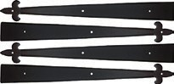
Stamped 17”
Fleur-de-Lis Straps 4/pack

Fleur-de-Lis 2/pack
6130499
6130491
6130492

Plastic Hardware Kits Track Options

Optional Post Paint Finish*

Raynor’s ColorWave™ features 1,500 Sherwin-Williams® next generation post paint system options for your garage door.
*Not all colors are available in solar reflective paint, colors that are not available as solar reflective cannot be used on polyurethane doors.

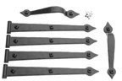
Screw Applied Colonial Kit 4051105

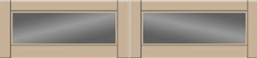
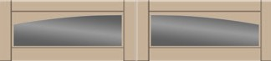
Window Options*
Galvanized (standard)
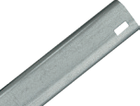

EnduraCote™ (optional)
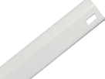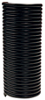

Panel Options
Swing-Out
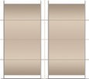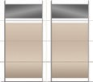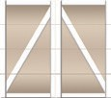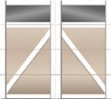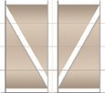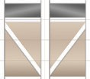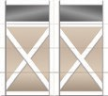
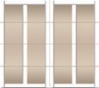
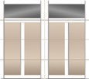
Bi-Fold Accordion
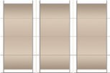 | 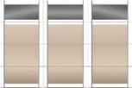 | 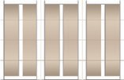 | 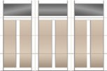 | 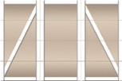
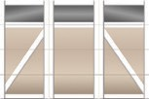 | 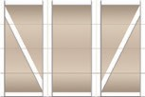 | 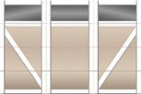 | 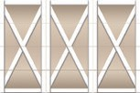 | 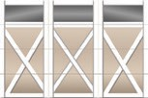

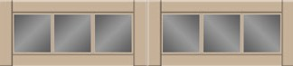
1 pane 1 pane arched 3 pane***

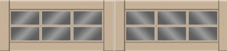
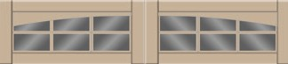
* Available in clear, water, and insulated glass
**Available in 4 over 4 pattern
- over 3 pane** 3 over 3 pane arched** ***Available in 4 pane pattern

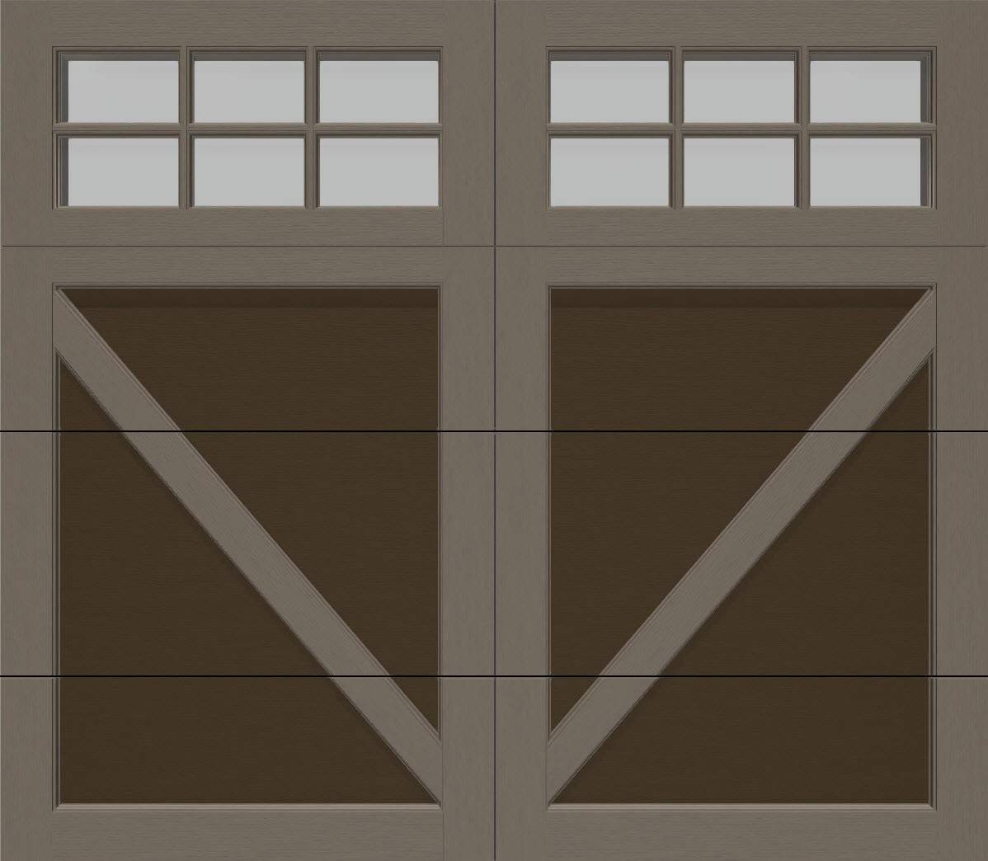

RockCreeke™

*Many other custom options available. Contact your Raynor dealer for further details.

With an inlay board design, this door is the ideal choice for a one of a kind carriage house look that will stand the test of time. Raynor's Country Manor is perfect balance between exceptional beauty and enduring quality. Country Manor is constructed with NeuFoam™ insulation which provides the ability to guard your garage against hot and cold temperatures; a WeatherLock™ section joint prevents air and water infiltration. Style and energy efficiency combine here to provide a comfortable climate in your garage.


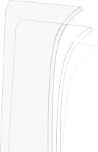





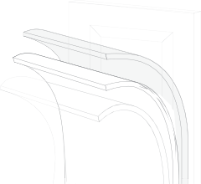



  - Baked-on finish
6
3
2
1
4
5
  - Epoxy primer
  - Galvanized layer
  - High-strength steel
  - Polyurethane insulation
  - High-strength steel

Country Manor, Slate, Mission with 4-over-4-square windows.

Colors
Start creating a beautiful, customized garage door design that fits your style by selecting from one of our many color options below

Standard Solid Colors
White
Almond
Desert Tan
Sandstone

Windows

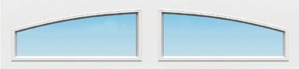
Square Two Piece Arched
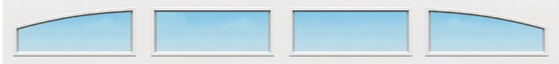
Peakview
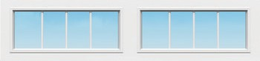
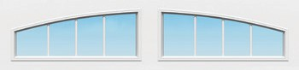
- Pane - Square 4 Pane - 2 Piece Arched

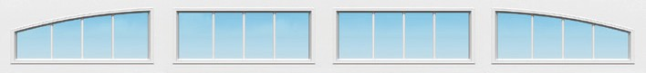

s

come standard with a Cool Chemistry™ pai
Black
Slate

Black steel door
Brown
Bronze

nt finish
Mission Vista

Panels
to protect from extreme heat. For environments where extreme heat and sunlight exposures are constant, black not recommended.
Wrought Iron - Square Wrought Iron - 2 Piece
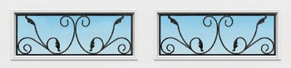
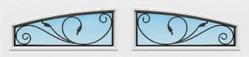
Arched


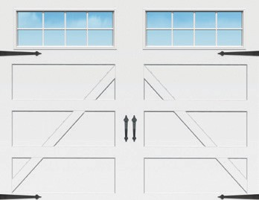
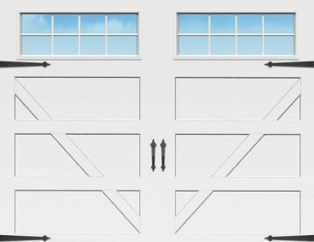
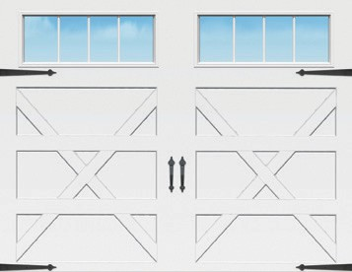
Revival Arch
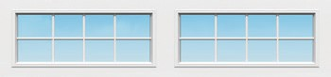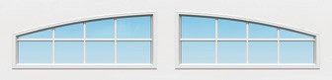

4-Over-4 - Square
4-Over-4 - 2 Piece Arched

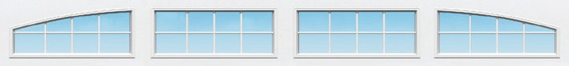

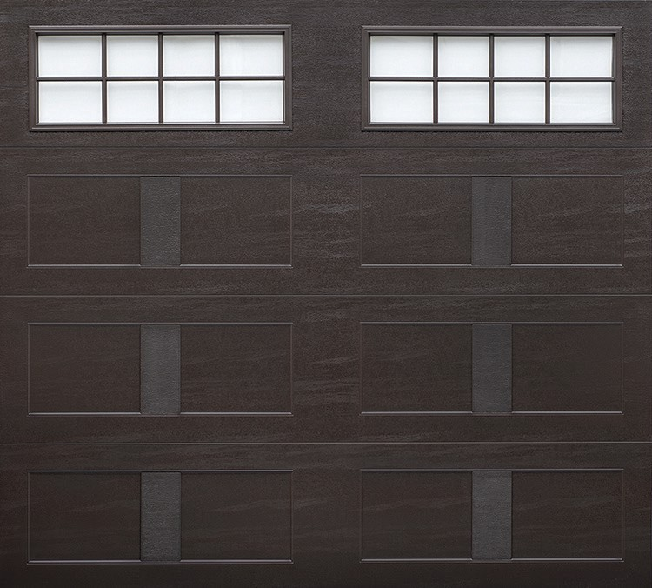
A-Buck

Country Manor™

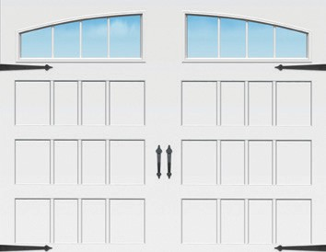
Swing
X-Buck V-Buck
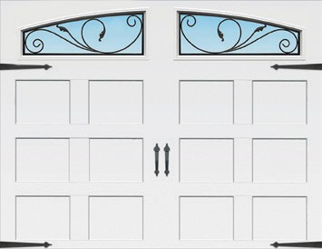
Mission

Glass
Spring Line

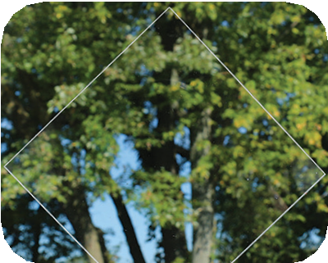
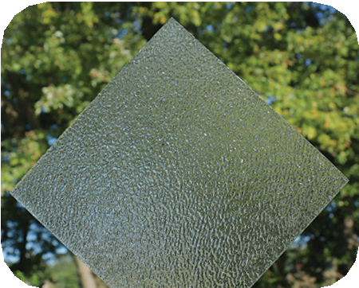
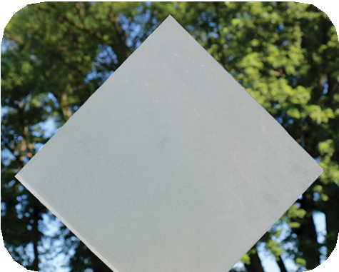
Clear Obscure Satin

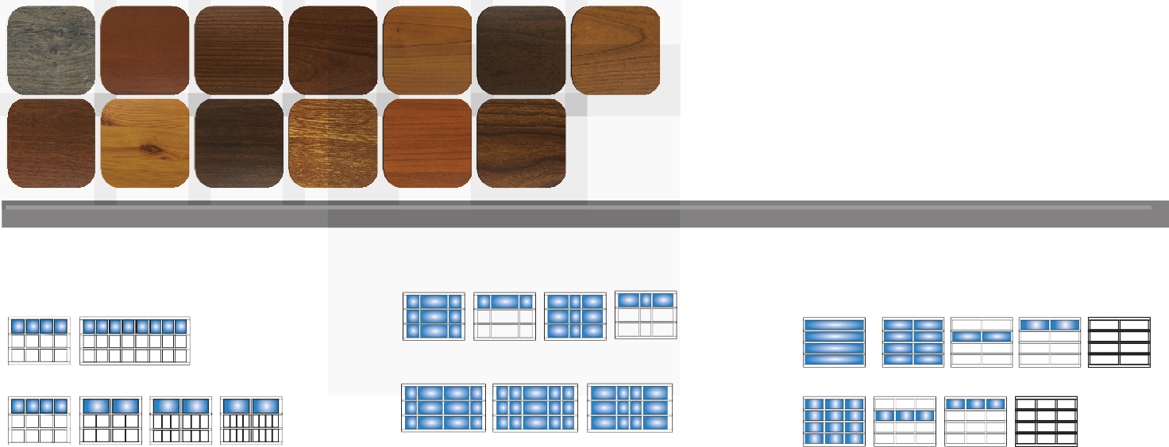
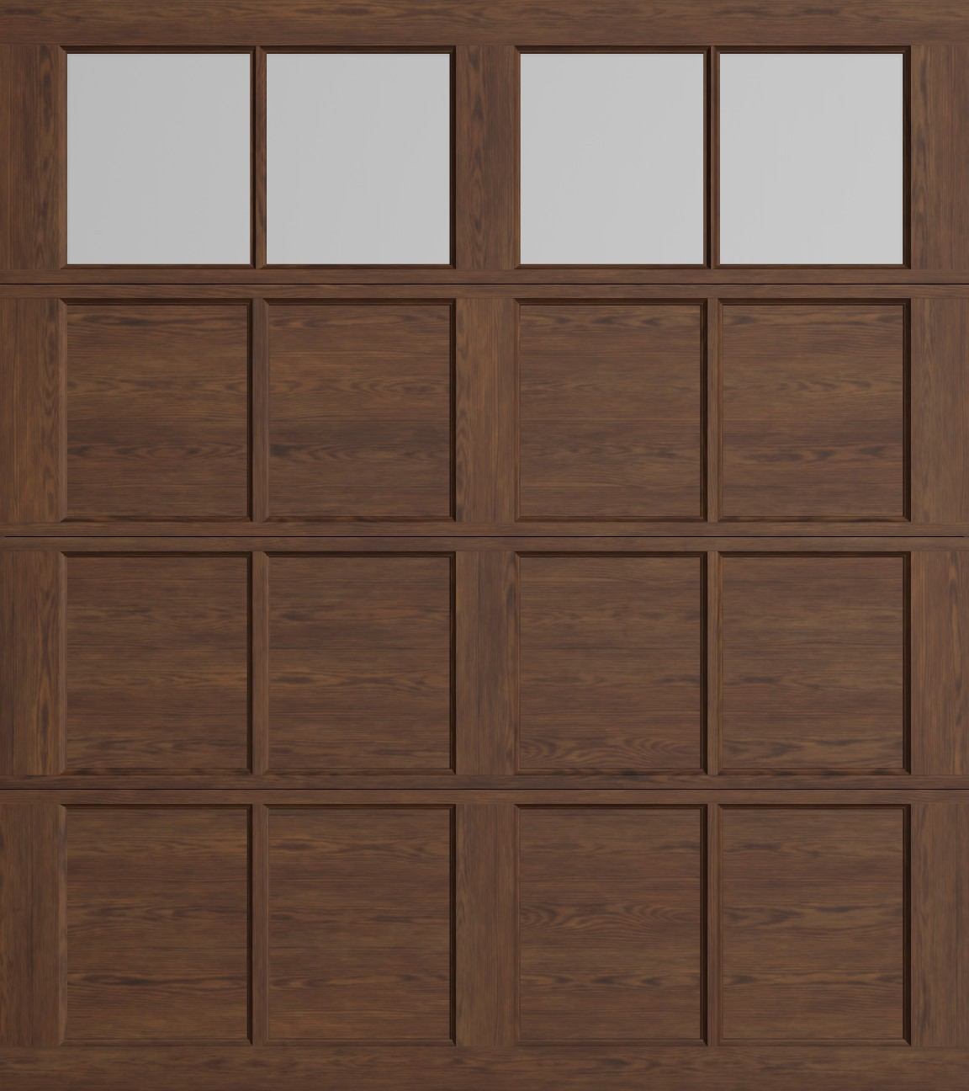
Raynor StyleView™
Clear
Dark Bronze
Black
An inspiration in both form and function, Raynor StyleView garage doors offer architectural flexibility, maximum visibility and extreme durability in a maintenance-free aluminum garage door.

ArmorBrite™ Color System
Choose from over 188 Raynor ArmorBrite™ colors.

Anodized Finish Options
(ArmorBrite equivalents are available for shorter lead times and easier touch ups)




Elegant Finish Woodtones™ Options

Aged Dark Oak
American Maple
Cherry Cherry Flame
Colony Maple
Dark Walnut
European Cherry

Golden Oak
Knotty Pine
National Walnut
Oak Table
Cherry
Teak

Raynor StyleView Narrow Profile

Panel Options

Custom Carriage House
Swing-Up

Custom Mixed Panel

Narrow & Wide Profile
Single Car
*

Swing-Out
MillCreek
MillCreek with Panels
Summitreef Summitreef
with Panels

Single car, 4'0" to 9'2", 2 panel design

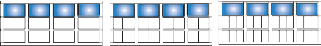
No batten

1 batten

2 batten 3 batten
Ridgelake
Bridgeport Shoreland

Single car, 9'3" to 12'2", 3 panel design
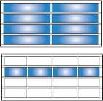
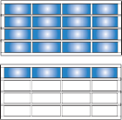
*

No batten 1 batten 2 batten
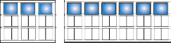
Accordion

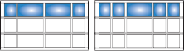

Ridgelake with panels


Bridgeport with panels

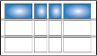

Shoreland with panels

No batten 1 batten
Bi-Fold
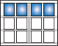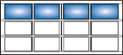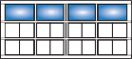
No batten No batten 1 batten
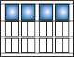
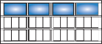
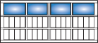
1 batten 2 batten 3 batten

Window Options

Custom Carriage House
Edgewater

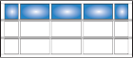
Edgewater with panels

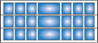
Springfield

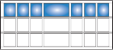
Springfield with panels
Baypoint

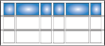
Baypoint with panels


Brookview

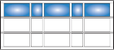
Brookview with panels
Highcrest


Highcrest with panels


Riverside

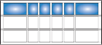
Riverside with panels
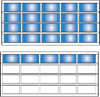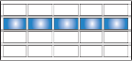
Double car, 12'3" to 20'0", 4 & 5 panel designs

Single-pane and two-pane options limited to 9'2" and 16'2" wide max, based on glass selection. Not all designs are available at all widths.
- Not available on narrow profile






1 Pane


2 Pane
2 Over 2 Pane

2 Over 2 Pane
3 Pane

3 Over 3 Pane
4 Pane

4 Over 4 Pane
Prairie (Simulated Only)

Aspen Series steel garage doors provide the ultimate in safety, quality, and energy efficiency in a steel, three-layer construction door design. The Aspen Series features Raynor’s proprietary WeatherLock™ section joint and seal system, NeuFoam™ polyurethane insulation, and a multitude of panel designs.

Aspen™ AP200LV Aspen™ AP200N
18.0
0.17
Tested U-Factor
Calculated R-Value
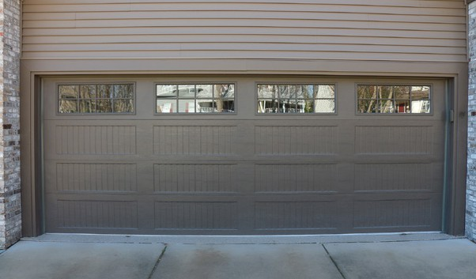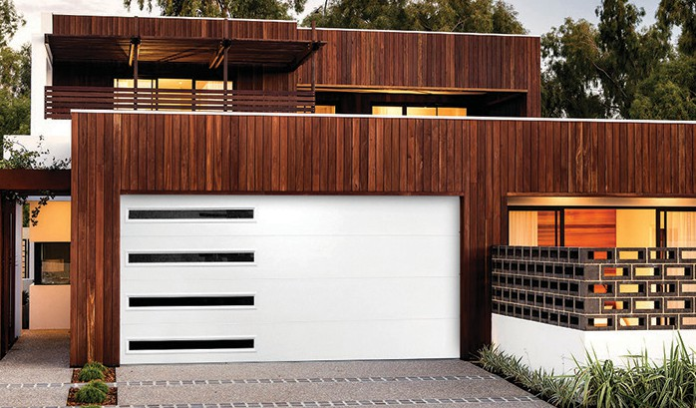
Tested U-Factor | 0.17
Calculated R-Value | 18.0


Environmentally Friendly
- Steel, two-sided
- 2” thick, NeuFoam™ polyurethane insulation
- Available in solid color or woodtone options
- Raised Colonial, Recessed Colonial Grooved, Raised Ranch, Recessed Ranch, Recessed Ranch Grooved, Flush and Plank panel designs
- Features Raynor WeatherLock™ section joint
- Optional EnduraCote™ hardware and track system
- Features “For As Long As You Own Your Home” Limited Warranty on sections and EnduraCote track and hardware, standard track and hardware 6-years and 3-years springs limited warranty*
- ColorWave™: Choose from 1,500 Sherwin-Williams® colors to custom match your door to your home
- 20% larger windows than the standard model
Environmentally Friendly
- Steel, two-sided
- 2” thick, NeuFoam™ polyurethane insulation
- Available in solid color or a woodtone option
- Flush and Plank panel designs
- Features Raynor WeatherLock™ section joint
- Optional EnduraCote™ hardware and track system
- Features “For As Long As You Own Your Home” Limited Warranty on sections and EnduraCote track and hardware, standard track and hardware 6-years and 3-years springs limited warranty*
- ColorWave™: Choose from 1,500 Sherwin-Williams® colors to custom match your door to your home
- Contemporary narrow profile windows

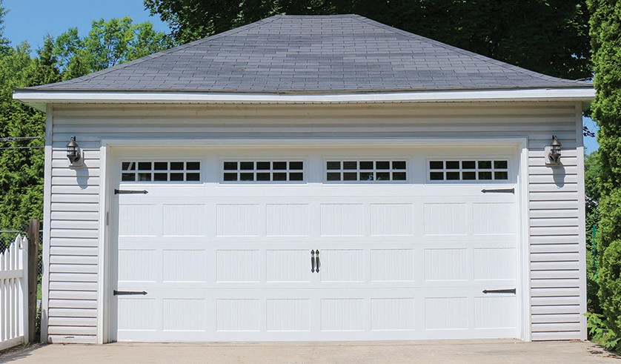



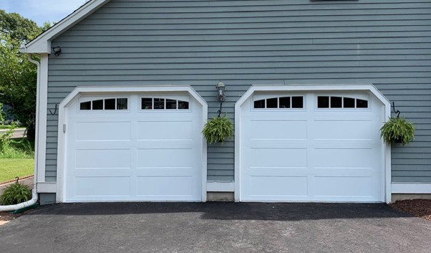


Aspen™ AP200 Aspen™ AP138
18.0
0.17
Tested U-Factor
Calculated R-Value
13.0
0.20
Tested U-Factor
Calculated R-Value

Wind Load Approved Environmentally Friendly
  - Steel, two-sided
  - 2” thick, NeuFoam™ polyurethane insulation
  - Available in solid color or woodtone options
  - Raised Colonial, Recessed Colonial Grooved, Raised Ranch, Recessed Ranch, Recessed Ranch Grooved, Mixed, Flush and Plank panel designs
  - Features Raynor WeatherLock™ section joint
  - Optional EnduraCote™ hardware and track system
  - Features “For As Long As You Own Your Home” Limited Warranty on sections and EnduraCote track and hardware, standard track and hardware 6-years and 3-years springs limited warranty*
  - ColorWave™: Choose from 1,500 Sherwin-Williams® colors to custom match your door to your home
Wind Load Approved Environmentally Friendly
  - Steel, two-sided
  - 1-3/8” thick, NeuFoam™ polyurethane insulation
  - Available in solid color or woodtone options
  - Raised Colonial, Recessed Colonial Grooved, Raised Ranch, Recessed Ranch, Recessed Ranch Grooved, Mixed, Flush and Plank panel designs
  - Features Raynor WeatherLock™ section joint
  - Optional EnduraCote™ hardware and track system
  - Features “For As Long As You Own Your Home” Limited Warranty on sections and EnduraCote track and hardware, standard track and hardware 6-years and 3-years springs limited warranty*
  - ColorWave™: Choose from 1,500 Sherwin-Williams® colors to custom match your door to your home

Aspen™ Series

* See www.raynor.com/products for complete and full Limited Warranty details.

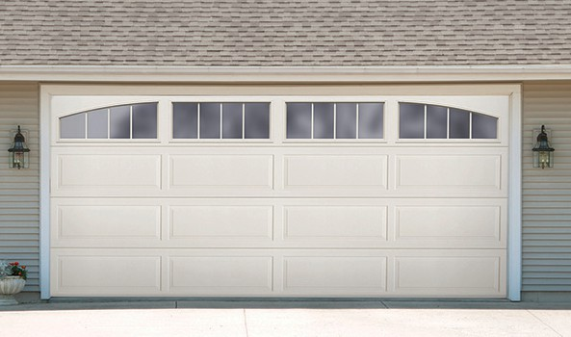
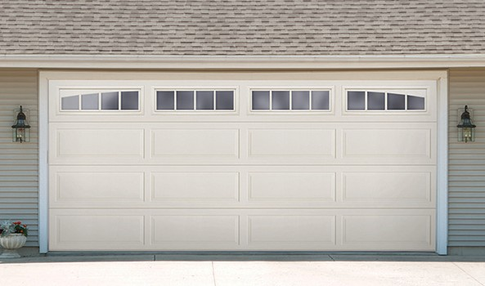
AP200LV LuxeVue™
AP200LV LuxeVue door by Raynor® combines all of the aesthetic design options of our Aspen™ Series line with a dramatically larger top window section to create a beautiful door, with stunning curb appeal.
Step out of the ordinary and compliment your home's aesthetic features with a LuxeVue™ door. The AP200LV is the perfect choice for a pristine, high-end, garage door.

Reference the LuxeVue brochure for more information on the AP200LV.
AP200LV Almond Ranch with Mission Vista Windows
Glass Options
All of our windows are tightly sealed to keep the elements out of your garage. Choose from either clear, obscure or satin glass styles.
Clear
Obscure
Satin
AP200LV Almond Ranch with Breckenridge Windows
Standard
LuxeVue™

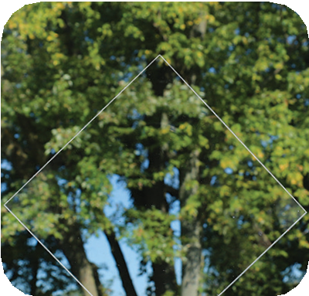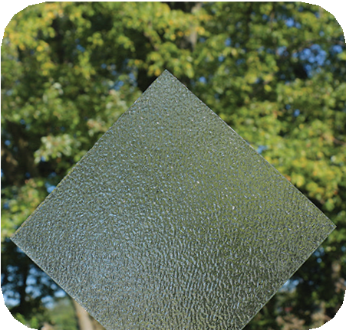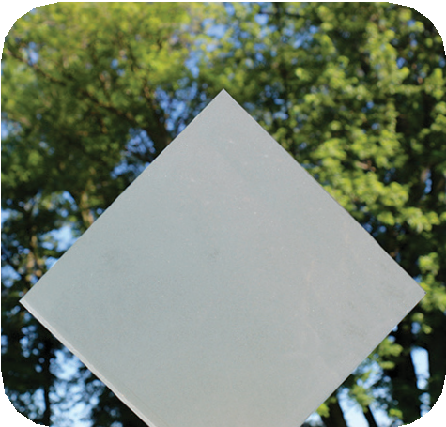

Window Options

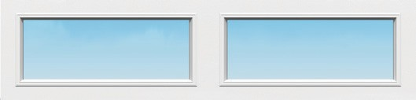 | 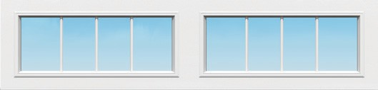 | 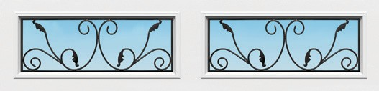 | 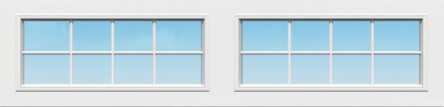
Square | 4 Pane - Square | Wrought Iron - Square | 4-Over-4 - Square
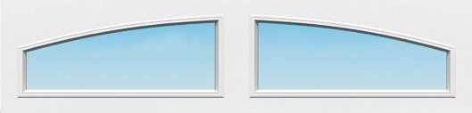 | 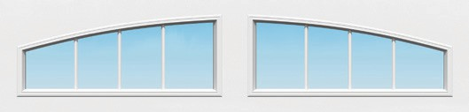 | 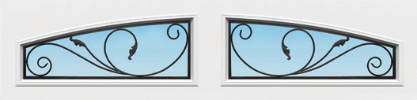 | 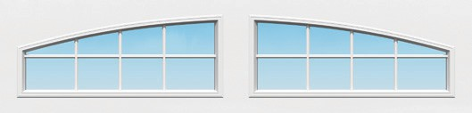
Two Piece Arched | 4 Pane - Two Piece Arched | Wrought Iron - Two Piece Arched | 4-Over-4 - Two Piece Arched
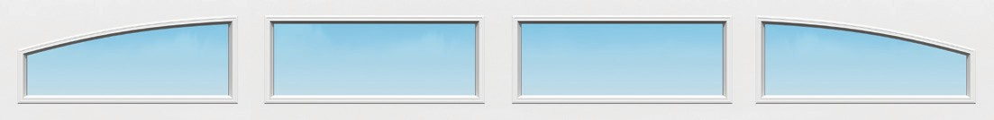 |  | 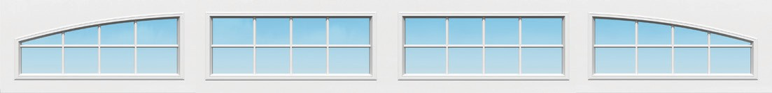
Peak View |  | Spring Line
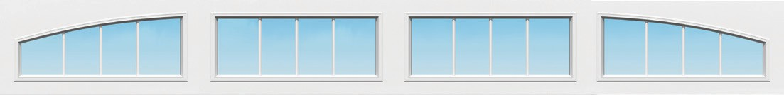 |  | 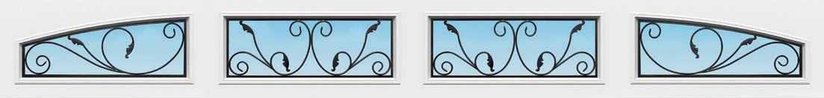
Mission Vista |  | Revival Arch

The Aspen Contempra model is built on a 2" Aspen base and provides clean, sleek lines for the ultimate contemporary look. A low profile, and narrow frame design, make a statement while still letting natural light into the garage without sacrificing privacy.

Panel Options

 | 
Flush | Plank

Colors*

Solid Color Options

Aspen Contempra, black with plank panels and satin glass

Glass Options
All of our windows are tightly sealed to keep the elements out of your garage. Choose from either clear, satin, or black satin glass styles.
sert Tan Sandstone
Brown
Iron Ore
Slate
Black
Charcoal
Bronze
De
Almond
White

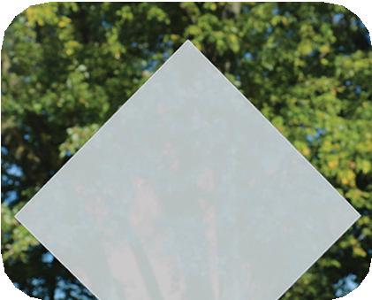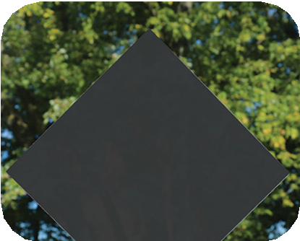
Clear Satin Black Satin

Aspen Elements™ Options
A collection of high-definition, digitally printed woodtone styles that embody the elemental allure of nature, blending rich grains and authentic textures to capture the essence of natural wood. Utilizing modern technology, these designs harmonize tradition with innovation, making a bold statement of style and refinement.
*Black satin available on insulated units only

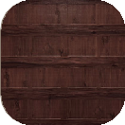
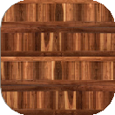
Dual Aspen Elements
Cocoa Hickory
Honey Cedar

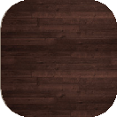
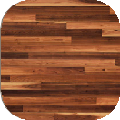
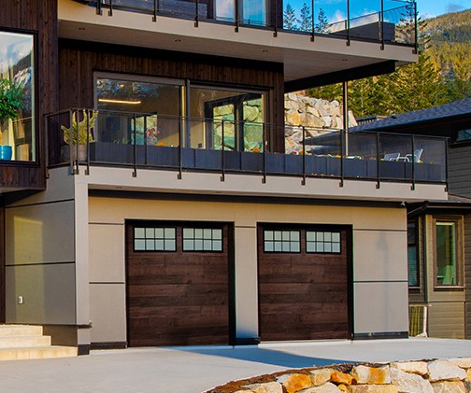
Plank Aspen Elements
Cocoa Hickory
Honey Cedar

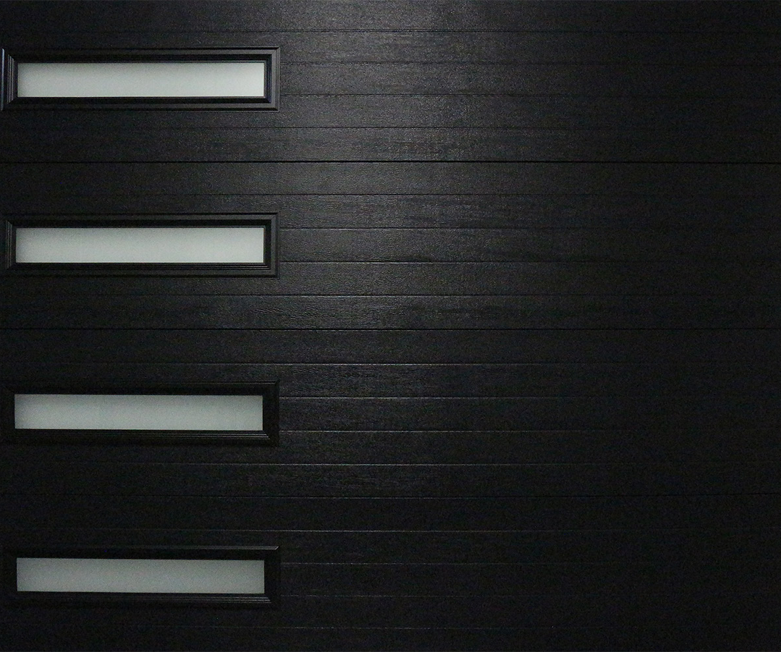

AP200N Contempra™

Optional Post Paint Finish*

Raynor’s ColorWave™ features Sherwin- Williams® next generation post paint system for your garage door. With 1,500 colors
to choose from, home and business owners can couple this elite paint

Raynor Aspen™ garage doors are available in two thickness options; 2” and 1⅜”. Both models feature NeuFoam™ insulation technology, ensuring that 100% of the section’s interior is filled with energy saving polyurethane insulation.

Aspen™ Panel Construction









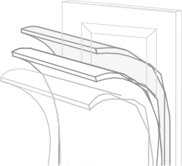




- Baked-on finish
4
6
3
2
1
5
- Epoxy primer
- Galvanized layer
- High-strength steel
- Polyurethane insulation
- High-strength steel
Aspen, black with colonial raised panel embossment and prairie windows.

*See www.raynor.com for complete and full Limited Warranty details.

Colors*

Solid Color Options
sert Tan Sandstone
Brown
Iron Ore
Slate
Black
Charcoal
Bronze
De
Almond
White

Aspen Elements™ Options
A collection of high-definition, digitally printed woodtone styles that embody the elemental allure of nature, blending rich grains and authentic textures to capture the essence of natural wood. Utilizing modern technology, these designs harmonize tradition with innovation, making a bold statement of style and refinement.

Hardware Options

Standard
Aspen doors feature galvanized steel track and hinges, Egyptian coated springs, and heavy-duty nylon rollers with steel ball bearings for long life and quiet operation.

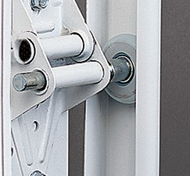
Optional
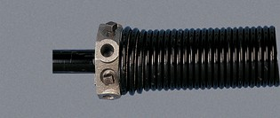
Raynor’s EnduraCote™ system includes white powder coated track, end stiles and hinges, black powder coated extended life springs and torsion bar. The EnduraCote™ option also extends the Limited Warranty* on hardware and springs to the original purchaser “For As Long As You Own Your Home” against defects in material and workmanship.

WeatherLock™ Section Joints



Aspen™ doors incorporate Raynor’s exclusive WeatherLock™ section joint. Raynor’s proprietary modified
Cocoa Hickory
Honey Cedar
Thermal Break - prevents heat
transfer
Air Infiltration Bulb Seal - prevents air leaks

Dual Aspen Elements
Cocoa Hickory
Honey Cedar

Optional Post Paint Finish*
Plank Aspen Elements
tongue-in-groove joint provides exceptional strength, moving the joint forward to increase effectiveness of the air and water seal, keeping out unwanted water and air infiltration, while providing unyielding section strength and integrity.


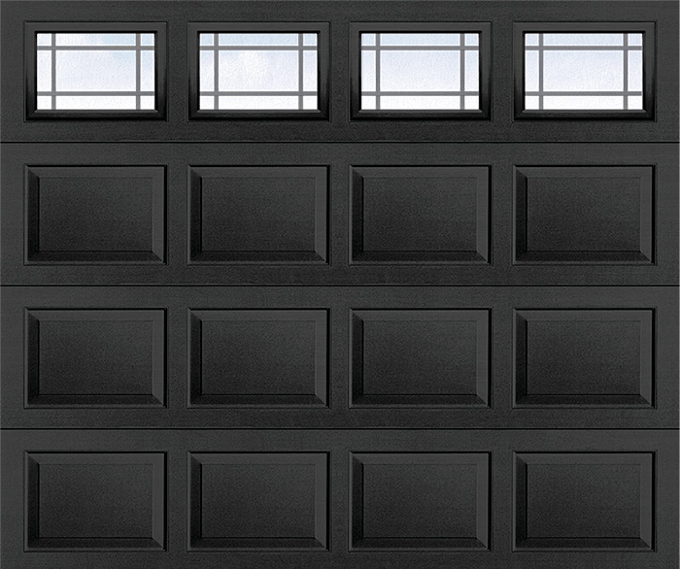
Raynor’s ColorWave™ features Sherwin- Williams® next generation post paint system for your garage door. With 1,500 colors

Aspen™ AP200 & AP138
to choose from, home and business owners can couple this elite paint

Panel Options*
Aspen™ offers distinctly different panel options to help give your home a custom and unique look.
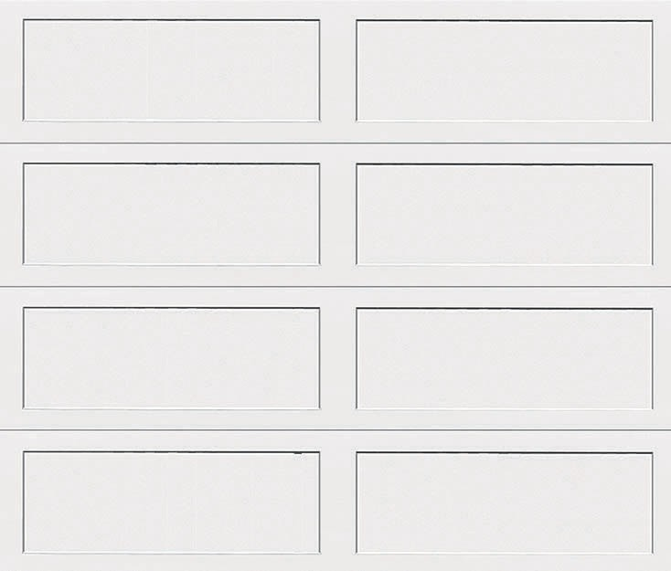 | 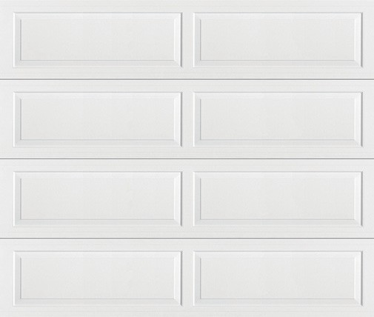 | 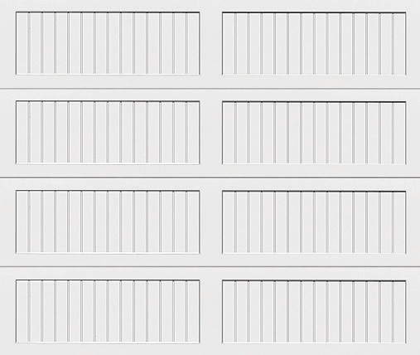 | 
Recessed Ranch | Raised Ranch | Recessed Ranch Grooved | Flush
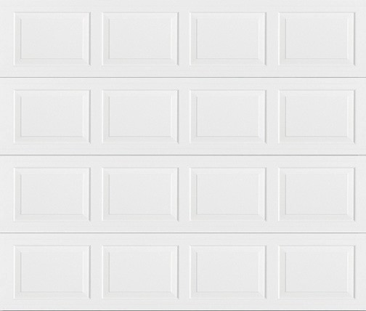 | 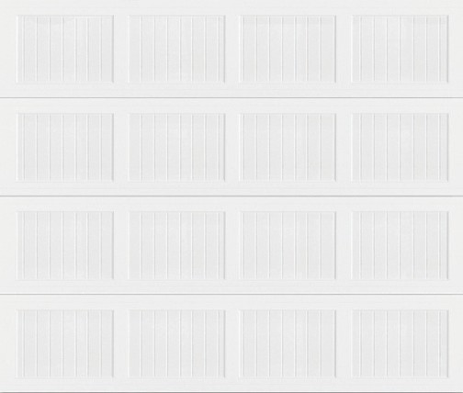 | 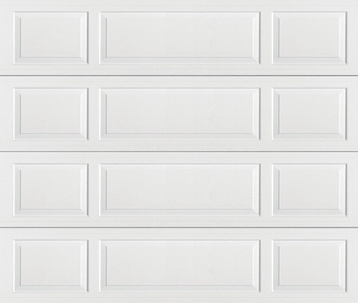 | 
Raised Colonial | Recessed Colonial Grooved | Mixed Panel | Plank

Optional Window & Decorative Hardware*
Raynor’s many window and decorative hardware options add the finishing touches to your Aspen™ door.
These small details customize the door to your home and increase curb appeal.

Window Options
Snap-In Inserts

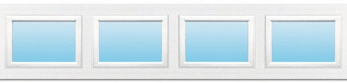 | 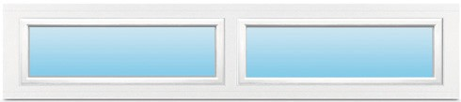
Clear Colonial | Clear Ranch
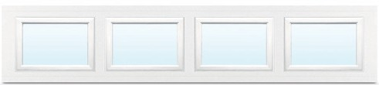 | 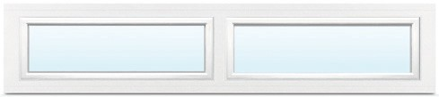
Obscure Colonial | Obscure Ranch

Decorative Hardware Options
*See Aspen Brochure for full selection.

Handles
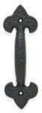

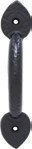
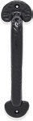
Cast Lift Cast Pull Cast Lift Cast Pull Cast Pull Stamped Stamped Low Profile Low Profile Handle Handle Handle Handle Handle Lift Handle Pull Handle Stamped Bean Stamped Handle Fleur-de-Lis Fleur-de-Lis Spear Spear Colonial Spade Spade Handles 2/pack Fleur-de-Lis 2/
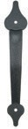
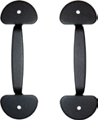
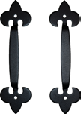
pack
Straps |  | Plastic Decorative Hardware Kits
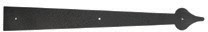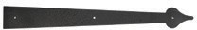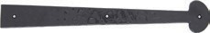  Stamped 16” Hinge Stamped 16” Hinge Narrow Cast 16” Hinge Colonial Spade (2” High) Spade (1⅝” High)  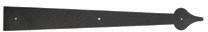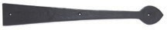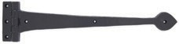  Stamped 24” Hinge Cast 16” Hinge Spear Cast 16” Hinge Assembly Spade Spear  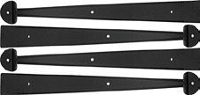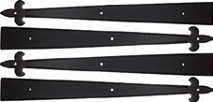  Stamped 17” Bean Straps Stamped 17” Fleur-de-Lis 4/pack Straps 4/pack |  | 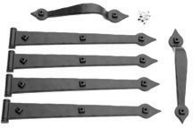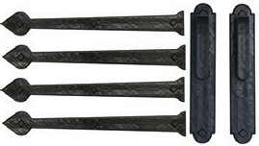  Screw Applied Colonial Kit Magnetic Manor Kit  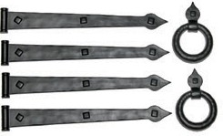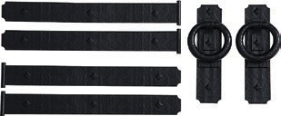  Magnetic Antique Ring Kit Magnetic Mission Kit  *See Aspen Brochure for full selection.
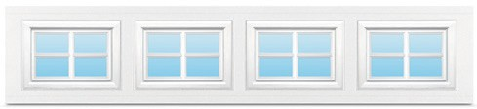 | 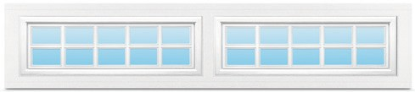
Stockton Colonial | Stockton Ranch
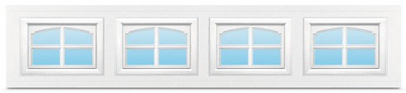 | 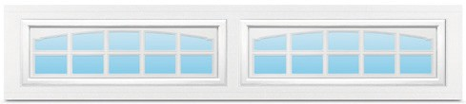
Cascade Colonial | Cascade Ranch

Colonial |  | Ranch |  | Mixed Panel
1-Car | 2-Car | 1-Car | 2-Car | 1-Car | 2-Car
 | 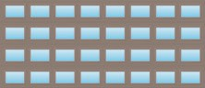 | 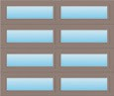 | 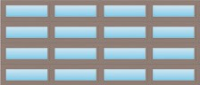 | 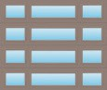 | 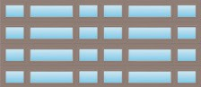
 | 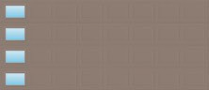 | 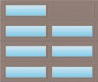 | 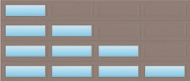 |  | 
 | 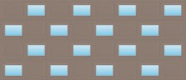 |  | 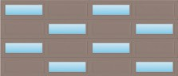 |  | 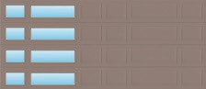
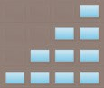 | 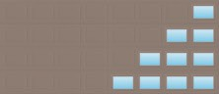 |  |  |  | 
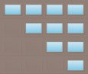 | 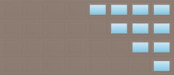 |  | 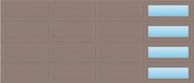 | 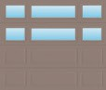 | 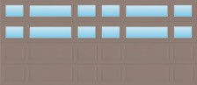

Glass Options
All of our windows are tightly sealed to keep the elements out of your garage. Choose from clear, obscure satin, black satin or dark tint glass styles.
Clear Obscure Satin
AP200 VersaView Walnut Ranch with Full View Windows
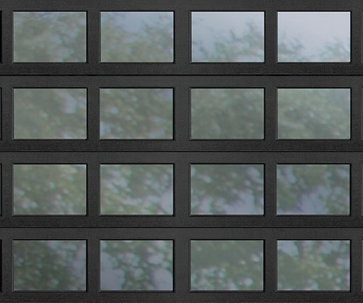

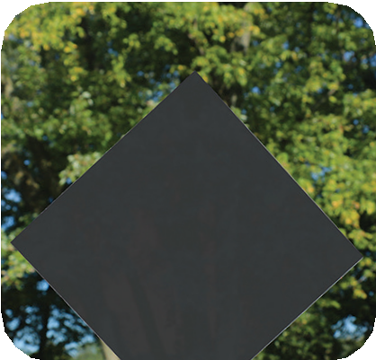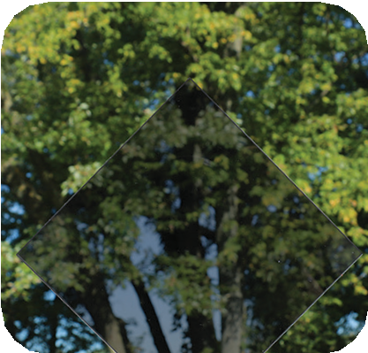

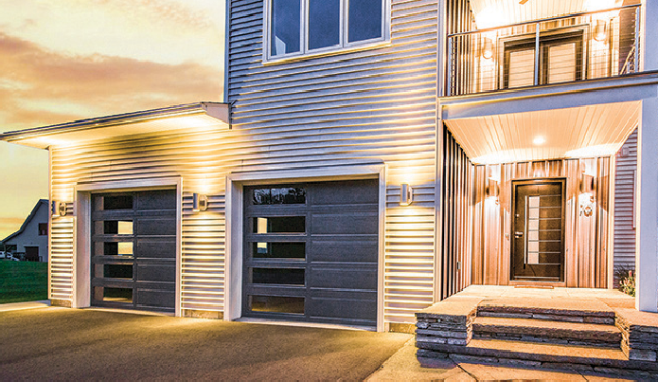
Black Satin*

AP200 VersaView
With Raynor's VersaView door, you have the ability to place windows in
any location on your door. Create a contemporary look with a vertical row of windows, or get creative in your window placement for a one of a kind look. The VersaView offering increases the amount of light inside your garage while improving the look of your garage door with stylish designs that enhance the curb appeal of your home! Your Raynor Dealer can build you a door with a unique look using the customizable window placement available with the VersaView program for our Aspen AP200 doors.
Dark Tint

*Black Satin available on insulated units only

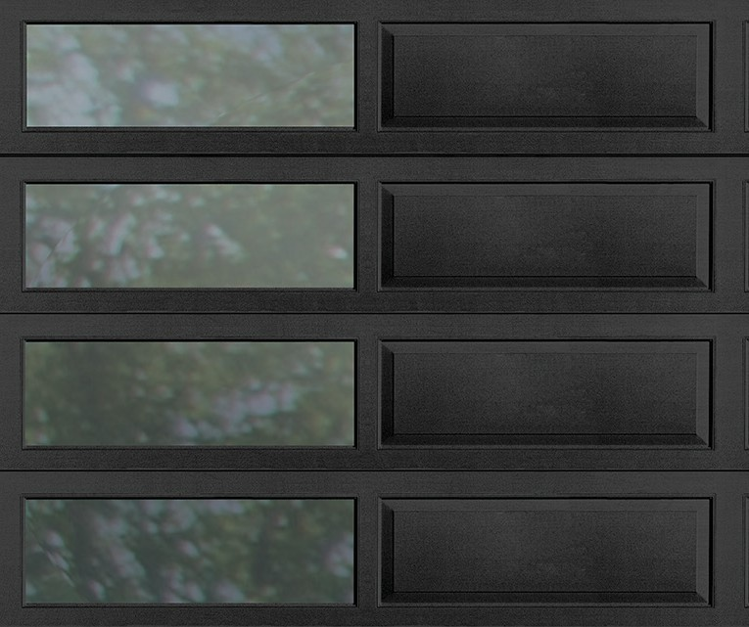
VersaView available on 2” Aspen doors only. Tempered glass must be used when placing windows in the bottom 2 sections. Max door size of 18’ 2" wide x 10’0" high. Recessed ranch panel option is not available with windows if there is an 18" section in the stack.

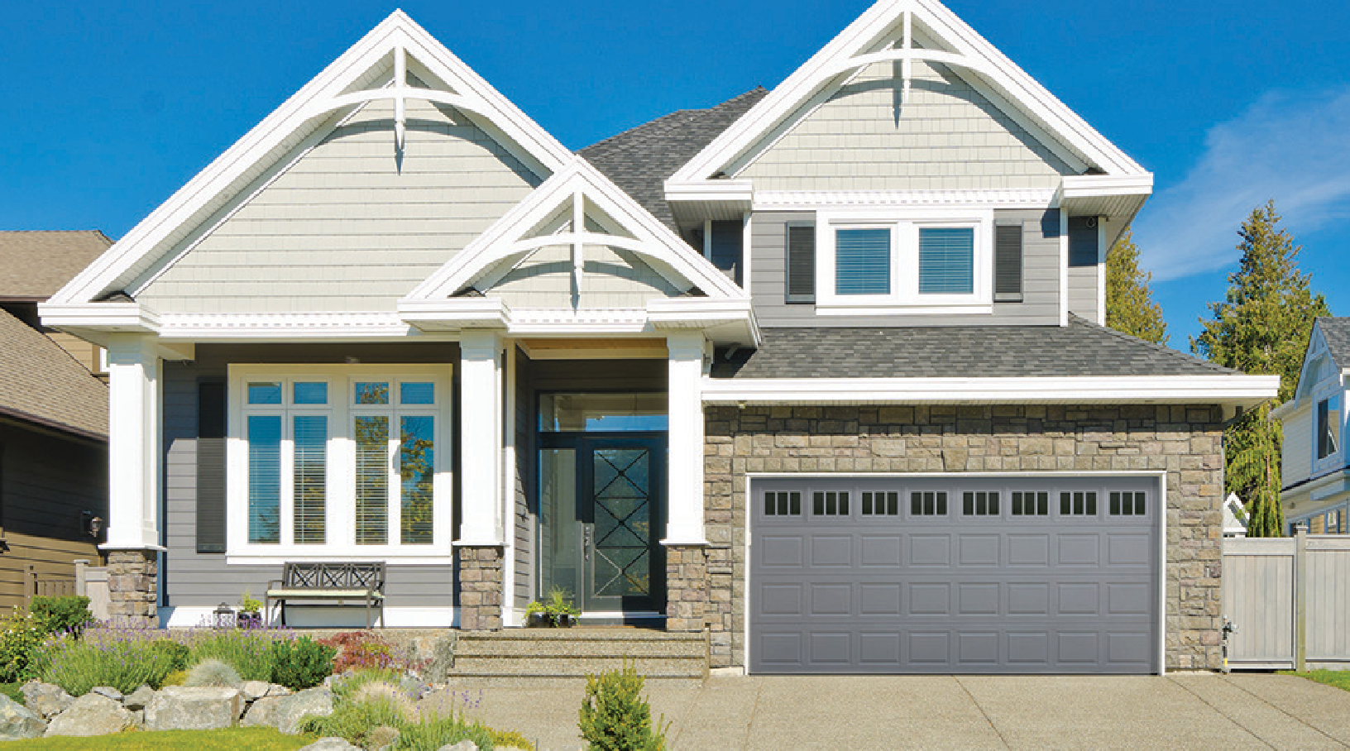
Encore™ - EN200 • Grey • Colonial • Stockbridge Colonial Windows

Encore Series™
Encore Series steel garage doors are beautifully designed with the homeowner in mind. These doors are strong, durable, and offer thermal benefits in a wide variety of custom design options at a competitive price.

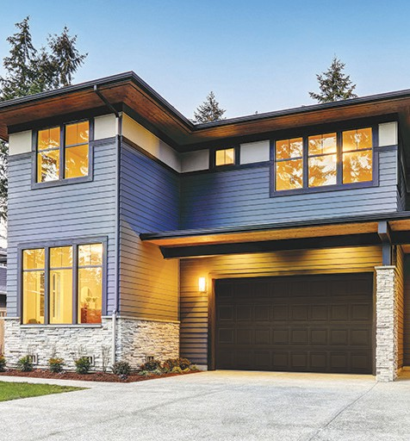
Encore™ EN200
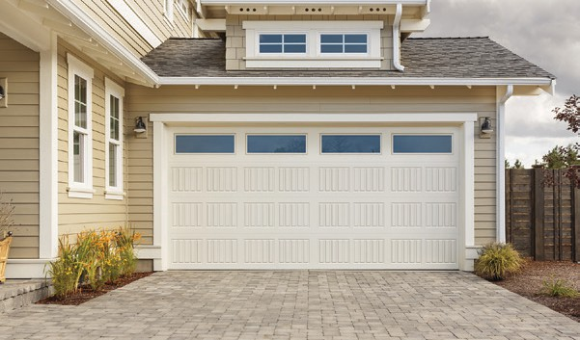
 Wind Load Approved  Environmentally Friendly
- Steel, two-sided
- 2” thick, polystyrene insulation
- Available in 9 solid color options and a single directional woodtone option
- Colonial, Ranch, Flush, Colonial Carriage, Ranch Carriage, Plank and Shaker panel designs
- Multiple window options available
- Industry or Raynor Track and Hardware packages available
- Features “For As Long As You Own Your Home” limited warranty on section*

* See www.raynor.com/products for complete and full Limited Warranty details.

The Raynor Encore steel two-sided residential garage door boasts both beauty and practicality. Its 2" thick sections feature a core of polystyrene insulation bonded between two high-strength, steel skins for a thermally beneficial option resulting in a 10.0 calculated R-Value*. A variety of options paired with a gunite surface texture, embossed panels and thermal benefits, give homeowners the perfect door to enhance the look of their home at an economical price point.

Colors


Standard Solid Colors White Ivory
Brown
Taupe
Desert Tan

Optional Solid Colors
Shale Grey Black Red

Optional Single Directional Woodtone
Mocha*

on monitors and printed materials may vary from the actual color. For a true representation of the color, visit your local Raynor Dealer.
The swatches shown

Window Options
Panel Options
Maximum opening door size*: 20’0” wide (1” increments) x 10’ high (3” increments)

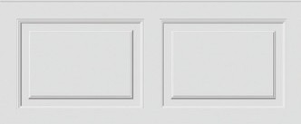 | 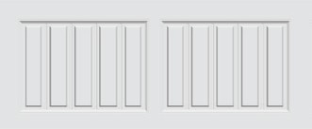 | 
Colonial | Colonial Carriage | Flush
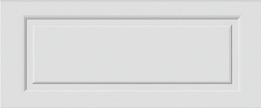 | 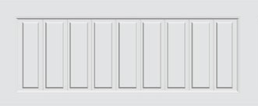 | 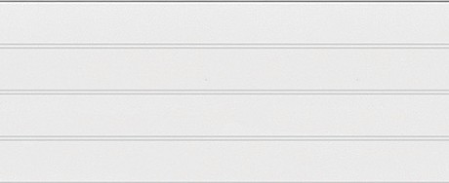
Ranch | Ranch Carriage | Plank
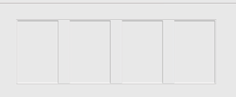
Shaker

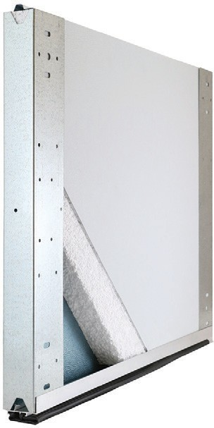


Encore™ EN200
3
*Pending testing in accordance with DASMA TDS-163
Encore, white with shaker panel embossment
2
- High-strength steel
- Polystyrene insulation
- Bottom seal
1
 | 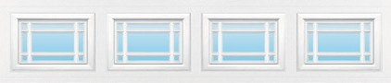 |  | 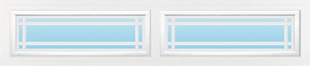 | 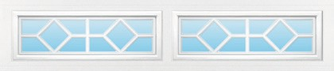
Colonial | Prairie Colonial | Ranch | Prairie Ranch | Waterton Ranch
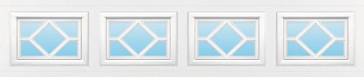 | 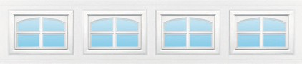 | 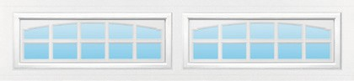 | 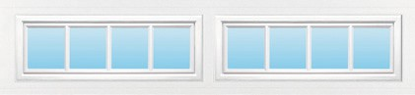 | 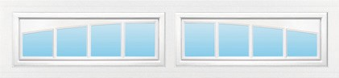
Waterton Colonial | Cascade Colonial | Cascade Ranch | Stockbridge Ranch | Arched Stockbridge Ranch
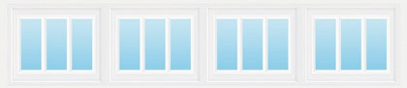 | 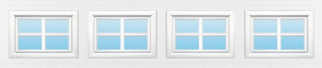 | 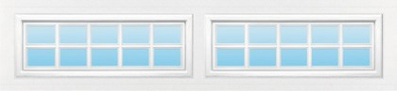 | 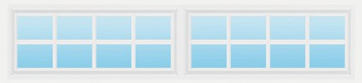 | 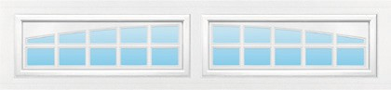
Stockbridge Colonial | Stockton Colonial | Stockton 10-Pane Ranch | Stockton 8-Pane Ranch | Arched Stockton 10-Pane Ranch
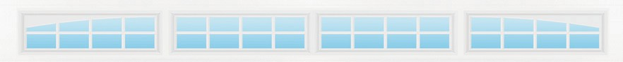 |  | 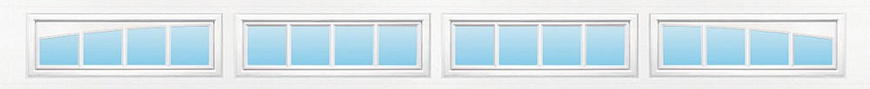 |  | 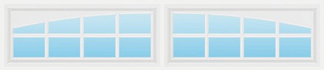
Berkshire 8-Pane Ranch |  | Breckenridge |  | Arched Stockton 8-Pane Ranch
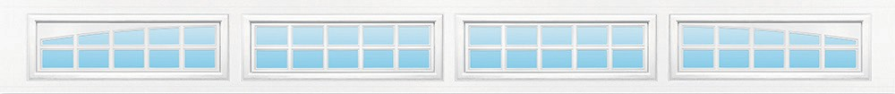
Berkshire 10-Pane Ranch

Advantage Series™
Advantage Series garage doors offer homeowners, builders, and contractors a solid pan door option with a wide-range of options and designs from which to choose.

TradeMark™ BuildMark®
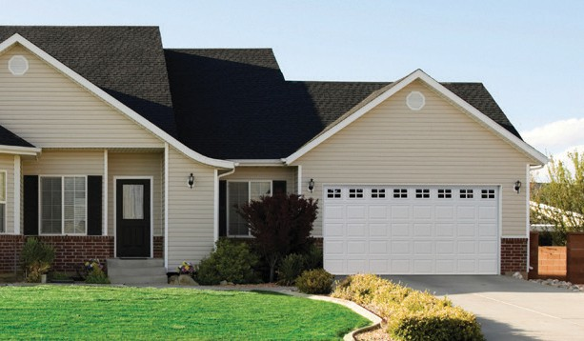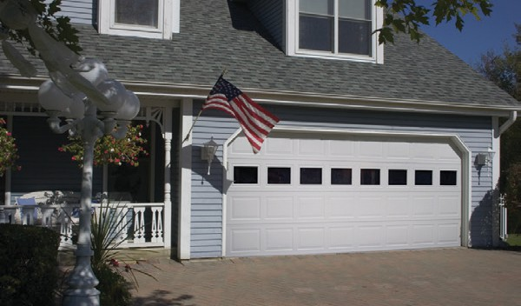



Wind Load Approved Environmentally Friendly
Wind Load Approved Environmentally Friendly



- Steel door (with optional polystyrene insulation)
- 24 gauge steel
- Available in 4 solid color options or ColorWave™
- Our beautiful window designs put the finishing touch on your garage door. Choose from clear or obscure single pane glass. Snap-in window designs add charm to any home. A variety of styles lets you customize your look!
- Features limited lifetime rust-through section warranty, 6-years track & hardware limited warranty and 3-years springs limited warranty*
- Steel door (with optional polystyrene insulation)
- 25 gauge steel
- Available in solid colors and ColorWave™ options
- Our beautiful window designs put the finishing touch on your garage door. Choose from clear or obscure single pane glass. Snap-in window designs add charm to any home. A variety of styles lets you customize your look!
- Features limited lifetime rust-through section warranty, 6-years track & hardware limited warranty and 3-years springs limited warranty*

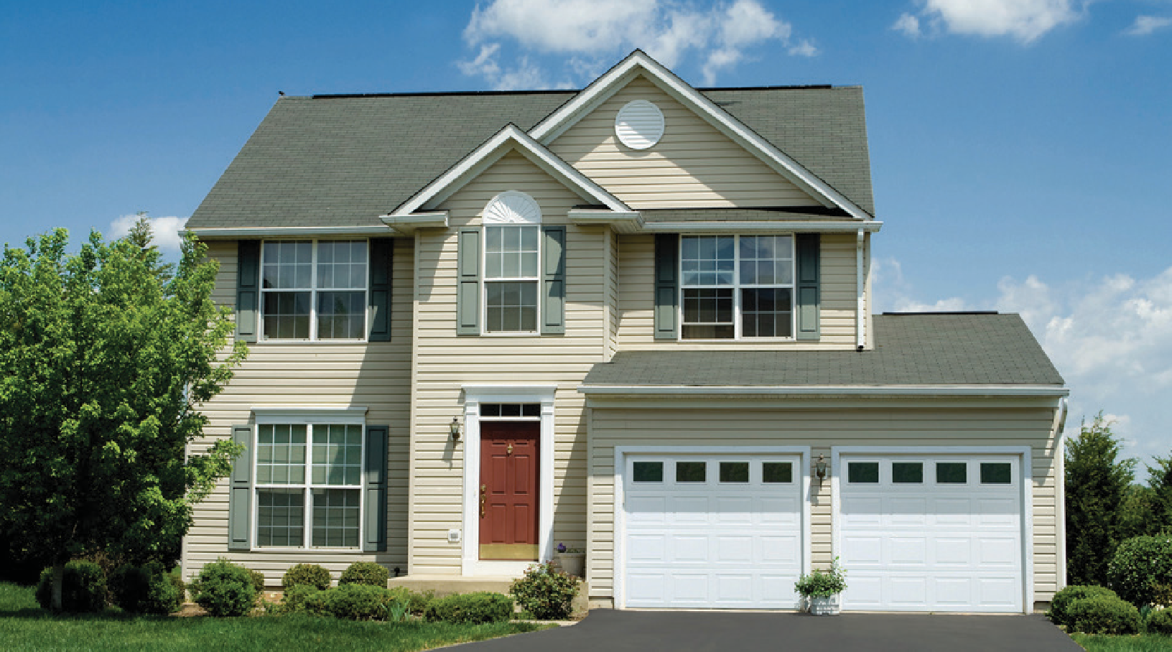
TradeMark™ - White Colonial with Clear Colonial Windows

* See www.raynor.com/products for complete and full Limited Warranty details.

The combination of durable, 24-gauge steel, defined raised panel styling and authentic woodgrain texture gives your home curb appeal with TradeMark steel garage doors. Add charm with colonial or ranch panels, or for a distinctive look on your home, choose the colonial recessed grooved style. Optional polystyrene insulation can be added to provide additional comfort and help keep your garage quieter.

- Baked-on finish
- Epoxy primer
- Galvanized layer
- High-strength steel
- Optional polystyrene insulation

TradeMark, Ranch, with Cascade Ranch inserts

Colors
Standard Solid Colors
White Almond
Standard
Bronze
Brown

Panel Options*

Colonial Ranch

Optional Post Paint Finish*
 Raynor’s ColorWave™ features Sherwin-Williams® next generation post paint system for your garage door. With
1,500 colors to choose from, home and business owners can couple this elite paint system with state of the art Raynor manufacturing to craft the perfect look for their home or project.
*Not all colors are available in solar reflective paint, colors that are not available as solar reflective cannot be used on polyurethane doors.

Hardware Options

Colonial Recessed Grooved

Window Options
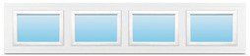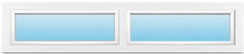
Clear Colonial Clear Ranch
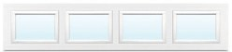
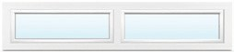
Obscure Colonial Obscure Ranch

Snap-In Inserts

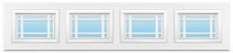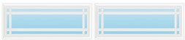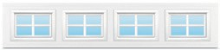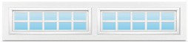







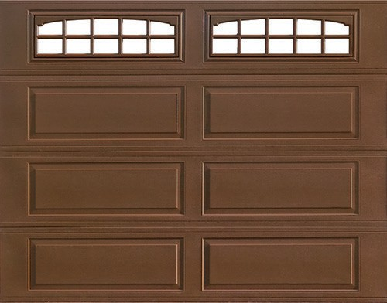

See Raynor Dealer for full hardware selection.
4
2
1
3
5

TradeMark™

Hardware
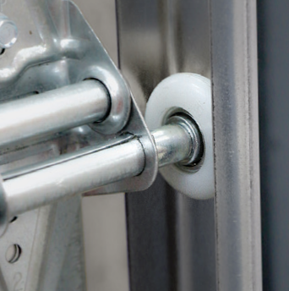
TradeMark doors feature galvanized steel hardware.

Insulation Options
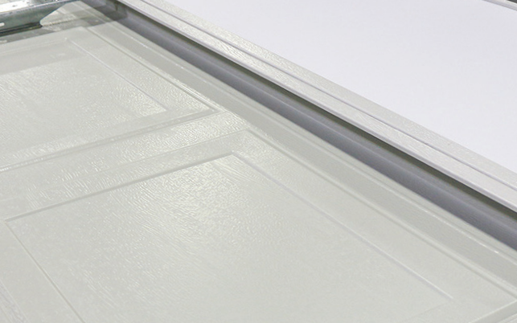
An energy-saving core of polystyrene insulation provides added comfort and helps keep your garage quieter.
Insulated

Non-Insulated
Prairie Colonial Prairie Ranch

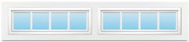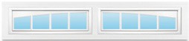
Stockbridge Ranch Arched Stockbridge
Decorative Hardware |  |  |  | Straps
 | Fleur-de-List Handle | 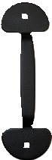 | Bean Handle | 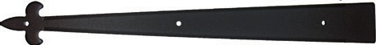
 |  |  |  | Fleur-de-Lis
 |  |  |  | 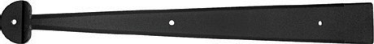
 |  |  |  | Bean

Ranch
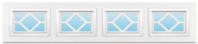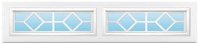
Waterton Colonial Waterton Ranch

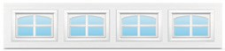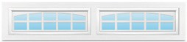
Cascade Colonial Cascade Ranch
Stockton Colonial Stockton Ranch
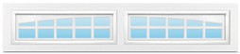
Arched Stockton Ranch
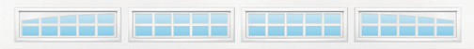
Berkshire

Breckenridge

This steel garage door design offers a traditional look at an affordable price. Choose from the time-honored ranch and colonial patterns or customize your garage with a colonial recessed grooved style. Optional polystyrene insulation can be added to provide additional comfort and help keep your garage quieter.

- Baked-on finish
- Epoxy primer
- Galvanized layer
- High-strength steel
- Optional polystyrene insulation

BuildMark, Colonial, with Cascade Colonial inserts

Colors

Standard Solid Colors
Standard
White Sandstone Almond
Desert Brown Tan

Optional Solid Color
Black

Hardware Options

Optional Post Paint Finish*

Raynor’s ColorWave™
features Sherwin-Williams® next generation post paint system for your garage door. With 1,500 colors to choose from, home and business owners can couple this elite paint system with state of the art Raynor manufacturing to craft the perfect look for their home or project.
*Not all colors are available in solar reflective paint, colors that are not available as solar reflective cannot be used on polyurethane doors.

Panel Options*

Colonial Ranch

Colonial Recessed Grooved

Window Options
Clear Colonial | Clear Ranch
Obscure Colonial | Obscure Ranch

Snap-In Inserts
Decorative Hardware |  |  |  | Straps
 | Fleur-de-List Handle |  | Bean Handle
 |  |  |  | Fleur-de-Lis
 |  |  |  | Bean

Prairie Colonial | Prairie Ranch
Stockbridge Ranch | Arched Stockbridge Ranch
Waterton Colonial | Waterton Ranch
Cascade Colonial | Cascade Ranch

Stockton Colonial Stockton Ranch

See Raynor Dealer for full hardware selection.

Hardware
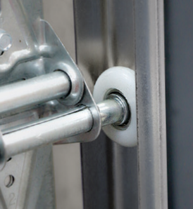
TradeMark doors feature galvanized steel hardware.

Insulated Options
An energy-saving core of polystyrene insulation provides added comfort and helps keep your garage quieter.
Arched Stockton Ranch
Berkshire
Breckenridge







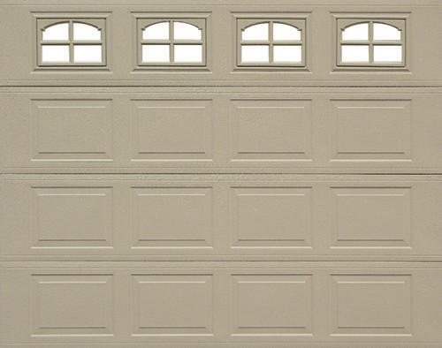
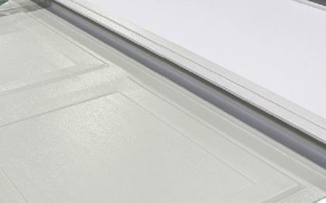
4
2
1
3
5

BuildMark®
Insulated

Non-Insulated

Raynor offers a full line of residential openers, featuring a variety of horsepower and configuration options. All of our operators feature myQ™technology, a patented, two-way communication system that allows users to open and close the garage door and manage other household devices from anywhere in the world via a Smart Phone. Ask your authorized Raynor dealer about our residential openers, and select the ideal Raynor opener for your home.

Raynor also offers a full range of smart accessories to enhance the safety and security of your home and garage! From smart cameras that easily mount to your existing opener, to smart door locks for your main entrance, Raynor’s got you covered! With Raynor Smart Accessories you will have peace of mind from anywhere, knowing the entrances to your home are secured!

Design Center
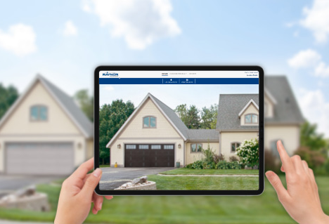

See what a new door can do to enhance the look of your home in real time on Raynor’s Garage Door Design Center. Select from our residential garage door models and customize your design on an uploaded image of your home or a stock photo. Visit www.designcenter.raynor.com to start designing today!
Exclusively Distributed by:

Follow Us
DASMA TPV Program

The DASMA Thermal Performance Verification (TPV) Program is a voluntary program to certify and verify the thermal performance ratings of sectional door products using third-party testing and inspection. The U-Factor on this model is verified through the DASMA TPV Program.

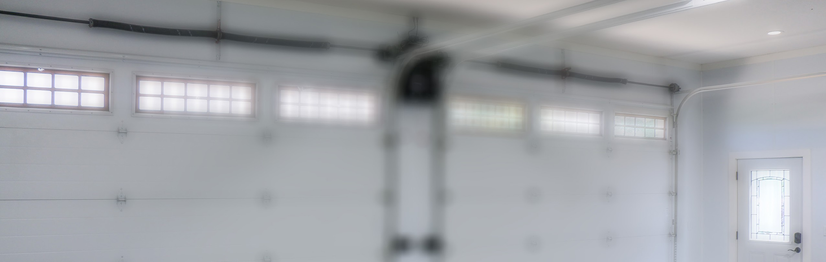
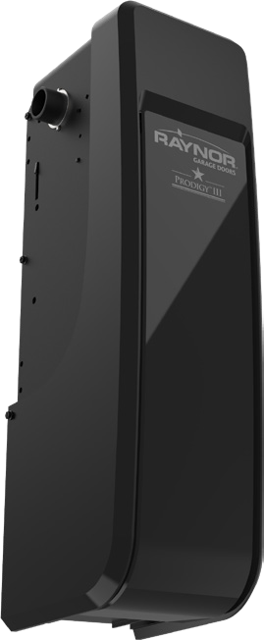


Residential Sectional Overview
Garage Door Openers & Smart Accessories
P.O. Box 448, 1101 East River Rd., Dixon, IL 61021-0448 1-800-4-RAYNOR (472-9667)
©2025 Raynor 2903849 1225


